Introduction to Section 3: Fungal Pathogens affecting Cannabis

Since the Wassons introduced the term, the public consciousness in the United States and other ‘mycophobic’ cultures have grown to acknowledge and appreciate the myriad fungi in our world that benefit us as humans and make our lives better (Wasson and Wasson, 1957). However, even today many farmers, as with humans generally, are blissfully unaware of the fungi all around them until one or more fungi impose a problem upon them. This section will focus on these scourges of cultivators -fungi capable of infecting and directly causing disease among Cannabis. Thus, many species mentioned will be household names to you already. Even so, some diseases, like ‘budrot,’ may actually comprise numerous pathogens causing similar disease symptoms. While the well known Botrytis may cause the majority of budrot experienced by Cannabis cultivators, species of Aspergillus, Penicillium, and Sclerotinia may all cause morphologically similar damage and disease on Cannabis.
Chapters in this section are organized by disease category (i.e. powder mildews, budrot, damping off, vascular wilt, ect.). Plant diseases are classified by the symptoms that plants express when infected with the pathogen, whether it be fungal, bacterial, or virus. Species capable of causing each disease presentation are listed in tables within the chapter, focusing on common and emergent pathogens.
Diseases caused by fungal pathogens can also be grouped by what part of the plant the fungus attacks. Broadly speaking there are foliar-infecting fungi, stem-infecting fungi (vascular wilts), root-infecting fungi can cause crown rot or significantly decrease root mass, and finally flower-infecting fungi which grow on the inflorescences of mature Cannabis crops (Punja 202).

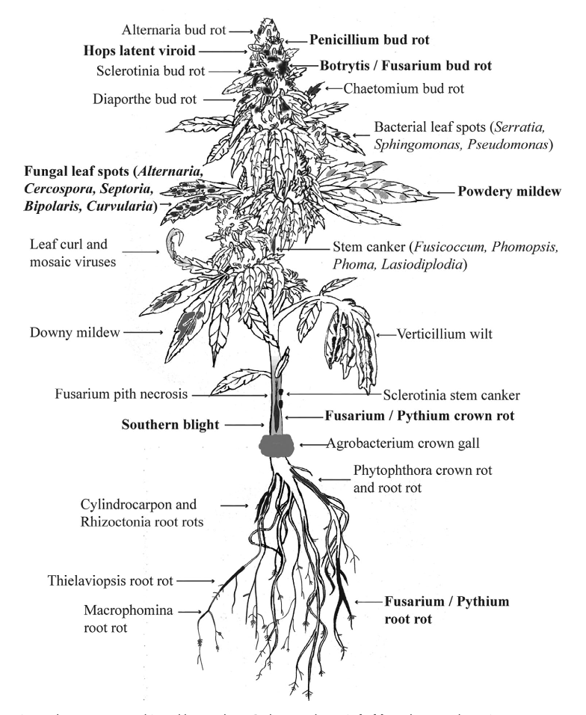
Figure 1. Anatomy of a flowering Cannabis plant and fungal diseases that infect different plant parts. (Punja 2021)

As Cannabis emerges as a mainstream crop in today's world, so does the science about its symbionts. Many pathogens remain undescribed and unknown to science even if individual farmers have already experienced them personally (HLVd was known as ‘dudding’ colloquially long before the viroid was known to exist). The United States Department of Agriculture, Agricultural Research Station maintains an excellent, up-to-date database of known fungal pathogens of Cannabis (and putatively any plant or fungal species for which information has been published).
Each chapter discusses the lifecycles and pathogen management options for causative species under different cultivation circumstances. Cannabis is incredibly diverse, as are the cultures and farmers who produce it. This is undeniably true for Cannabis in ways beyond any other crop. Farmers that are scaling up should lean on tried and true methods from traditional farmers that work at a field and farm level. Cultivators on a small scale have options open to no one else, particularly those growing indoors.

Section 3 Introduction Table 1. Disease Cannabis plants are susceptible to at different stages of the plants’ life cycle. X indicates the plants are susceptible, XX indicates the disease is regularly seen at that life stage and XXX indicates it is extremely common to see these fungal diseases at that stage of plant growth.
Stage of plant growth | Powdery Mildew | Bud rot | Damping off | Crown Rot | Canker | Leaf Spot
Cutting/seedling | X |  | XX |  |  | X
Vegetative | XX |  |  | XX | X | XX
Reproductive | XXX | XXX |  | XX | XX | XX
Post-harvest |  | XXX

Chapter 12
Powdery Mildew
Taxonomy
Kingdom: | Fungi
Phylum: | Ascomycota
Class: | Leotiomycetes
Order: | Erysiphales
Family: | Erysiphaceae
Genus: | Golovinomyces; Podospheara ; Leveillula
Species:  unresolved | Golovinomyces ambrosiae (Syn. G. cichoracearum, G. spadiceus); Podosphera macularis (formerly Sphaerotheca macularis); Leveillula taurica;

Introduction
One of the most ubiquitous and well known of the fungal pathogens on Cannabis are the powdery mildews. Caused by multiple organisms, this dreaded fungal disease first manifests itself as a white, cottony growth that begins to form on the top surface of leaves. Once conspicuous on the leaves, the spores of this fungus are likely to be everywhere in your grow, whether it is indoors or out.
However, there are various effective treatments that can eliminate this fungus (depending on the stage and degree of severity) and practices that can be used for preventing this fungus from getting established in the first place. Most growers have experience dealing with this fungus at one point or another. In many regions, PM is so common that one should assume that there are always going to be mildew spores in the air, unless you are growing in a filtered indoor space. Even then, starting with an assumption that you have spores in your garden will help you to develop and maintain a solid Integrated Pest Management program (IPM).
Just like everything else in the Cannabis industry, there are some clear misconceptions about these fungi that can be misleading and very confusing. To start with the confusing common names, powdery mildews and downy mildews are not the same disease and should not be treated in the same way. Downy mildew, caused by an oomycete rather than a fungus, is less commonly seen on Cannabis crops, though growers should still be aware of the pathogen and the symptoms associated with it (see “Chapter 16: Leaf Spot Diseases” for more information on Downy Mildews).
Elucidating the species of powdery mildews affecting Cannabis will assist cultivators in controlling the disease. Most species of powdery mildew are host specific and have limited alternate host ranges on which to hide from farmers whose crops may be affected (Table 1). Definitive knowledge of the species and pathovars affecting Cannabis will help us prevent cross-contamination from susceptible neighboring host plants. However, no matter which powdery mildew species you have any applied treatments will be the same.

Table 12.1. Alternative host range of powdery mildew species affecting Cannabis.
Species | Alternate hosts
Golovinomyces ambrosiae (Syn. G. cichoracearum, G. spadiceus). | Asteraceae (Acanthospermum, Ambrosia, Aster, Blainvillea, Chrysogonum, Coreopsis, Dahlia, Eupatorium, Gerbera, Helianthus, Lagascea, Laggera, Leucanthemum, Mauranthemum [Chrysanthemum s. lat.], Melampodium, Parthenium, Telekia, Tithonia, Xanthium, Zinnia), Fabaceae (Crotalaria), Malvaceae (Abelmoschus),Polygonaceae (Persicaria), Solanaceae (Solanum), and  Verbenaceae (Verbena).
Podosphera macularis | Humulus (americanus, lupulus, scandens [=japonica]), Moraceae
Leveillula taurica | Probably a species complex with unresolved host ranges:  Amaranthaceae (Amaranthus, Celosia, Gomphrena), Apocynaceae (Rauvolfia, Vinca) Aristolochiaceae (Aristolochia), Asclepiadaceae (Asclepias, Calotropis, Stapelia, Vincetoxicum), Bombacaceae (Asansonia, Bombacopsis), Burseraceae (Commiphora), Campanulaceae (Asyneuma, Phyteuma), Caricaceae (Coccinia, Cucumis, Cucurbita) Datiscaceae (Dattisca), Dipsaceae (Scabiosa), Grossulariaceae (Ribes), Daeodoraceae (Anigozanthos), Hydrophyllaceae (Phacelia), Hypericaceae (Hypericum), Linaceae (Linum, Reinwardtia, Malvaceae (Abelmoschus, Abutilon, Hibiscus), Martyniaceae (Martynia), Myrtaceae (Chamaelaucium), Oleaceae (Olea), Onagraceae (Clarkia Epilobium), Orobanchaceae (Leptorhabdos, Odontites), Plantaginaceae (Digitalis, Phlox, Polemonium), Polygonaceae (Polygonum, Rumex), Primulaceae (Samolus), Rosacea (Reseda), Salvatoraceae (Salvatora), Scrophulariaceae (Scruphularia), Tiliaceae ( Corchorus), Verbenaceae (Caryopteris, Lippia, Verbena).

There are accumulating reports identifying Golovinomyces cichoracearum sensu lato as the powdery mildew affecting Cannabis in Canada and France based on ITS sequencing (Pépin et al, 2018; Punja, 2018; Rodrigues et al, 2015) and G. spadiceus has been identified from Kentucky (Szarka et al, 2019). Golovinomyces spadicues is now named G. ambrosia and unfortunately G. cichoracearum sensu lato is poorly defined phylogenetically, likely comprising many cryptic species. There is also evidence that the ITS sequence alone does not adequately discriminate among closely related Golovinomyces species (Punja, 2018). These mixed and unclear results are not all that surprising given the fact that Cannabis has been illegal to grow and most scientists did not have the ability to work with this plant. Also, molecular fingerprinting has only been around since the mid-1980’s, with many organisms yet to be sequenced.
Macpartland et al. 2000 documented two species of powdery mildew infecting Cannabis: Leveillula taurica and Podosphaera macularis. However, under current nomenclature systems Podosphaera macularis is host restricted among Humulus species only (Uwe Braun, personal communication). This is contradicted by recent cross infectivity experiments, at least in greenhouse environments ( Weldon 2018). Most recently P. macularis has been found to cause natural infections on Cannabis plants in Oregon and Canada (Bates et al 2021, Punja et al 2021). Levieullula taurica was reported by Jaczewski, 1929, but has not been confirmed as a common cause of powdery mildew among Cannabis recently.
A private lab also reported an unknown genetic isolate from Cannabis grown in the Northeast United States. Researchers claimed a full genome sequence did not match any known Erysiphales in GenBank (a universal genetic depository for researchers), and that the northeast isolate was not from the genus Golovinomyces (Medicinal Genomics).
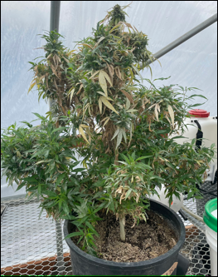
Figure 12.1. Host plant of Cannabis sativa being used to grow powdery mildew to inoculate future research projects for the development of powdery mildew controlling products. Since PM is obligate biotroph, researchers must keep PM alive on live Cannabis plants.

Powdery mildew is an obligate biotroph, meaning that it requires a host plant in order to complete its life cycle (live, grow, and reproduce). This characteristic makes obligate biotrophs incredibly difficult to study compared to saprophytic or necrotrophic fungi, since powdery mildews cannot be cultured in a petri dish or flask on nutrient media, rather they must be kept alive by growing the pathogen on a susceptible host plant (Fig. 1).
As noted before, powdery mildew can be extremely difficult to identify, even with a microscope (Fig 2). The keys that are available use very small, difficult to see features to distinguish among powdery mildew fungi. A major diagnostic feature for the identification of powdery mildew anamorphs (asexual state) are characteristics of the appressorium following conidia germination. Teleomorph identification can take advantage of the often unique, and beautiful, ornamentation on the sexual fruiting bodies (chasmothecia). However, chasmothecia are rarely formed on Cannabis.
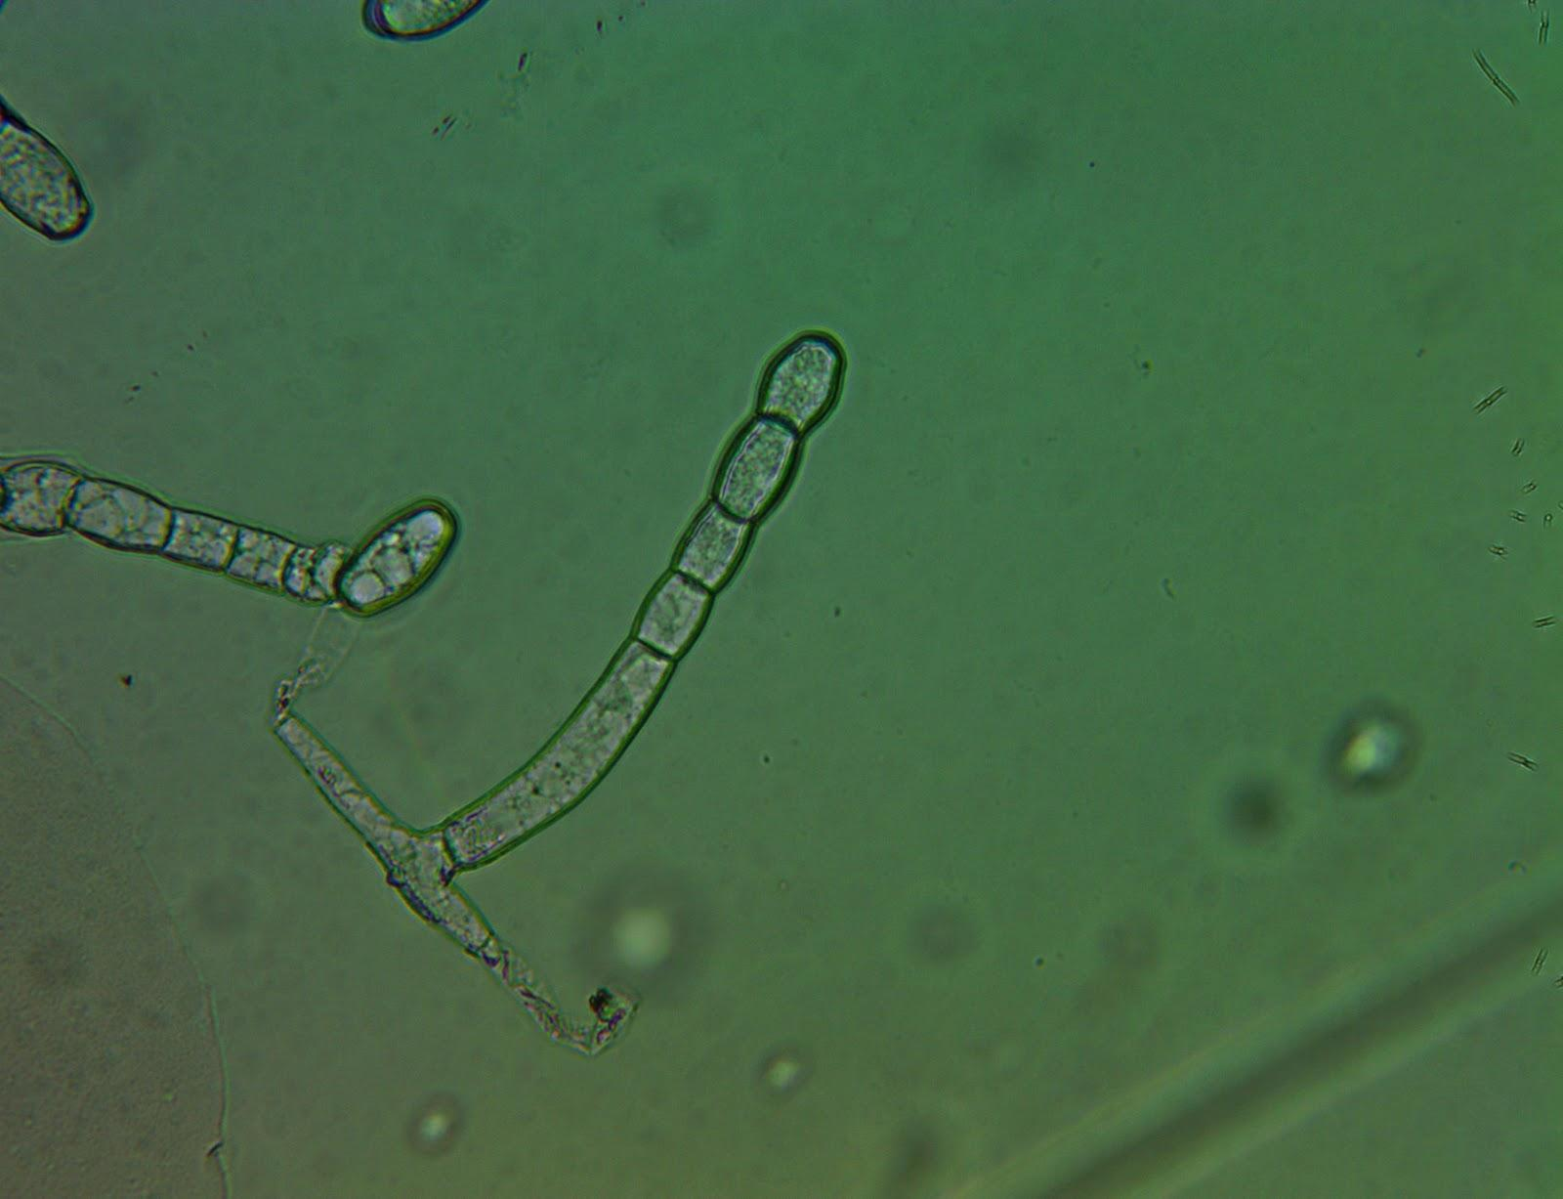
Figure 12.2. Powdery mildew (Golovinomyces ambrosiae) conidiophore found on Cannabis leaf surface grown in a greenhouse in Oregon. Tape mount at 40x

Accurate identification of many anamorphs is very difficult by diagnostic characters alone, and benefits from molecular techniques. Molecular techniques such as polymerase chain reaction (PCR) have enabled great strides in genetic sequencing, however these approaches also have limitations and are not widely available outside of academia and specialized private labs. Among fungi, the inter transcribed spacer (ITS) and ribosomal RNA of the large subunit (LSU rRNA) have often been used for phylogenetic analysis. Increasingly groups of genes are used to develop a consensus phylogeny, since single gene phylogenies based on the ITS sequence have been shown to be prone to error.
Like many other groups of fungi, the taxonomy of the Erysiphales (powdery mildews) is in a state of flux. As our understanding of the evolutionary relationships of each discrete species improves, names are changed and species are moved among taxonomic groupings so that our taxonomic system increasingly represents underlying phylogenetic relationships. There are certainly more than one species of Erysiphales affecting Cannabis which may have differing geographical distributions and host ranges. Definitive knowledge of the identity and geographic range of powdery mildew affecting Cannabis, as well as alternate host-plant species, will advance the ability of cultivators to effectively control pathogen outbreaks. It is likely that at least one of the PM species affecting Cannabis cultivators in North America has a relatively broad host range.
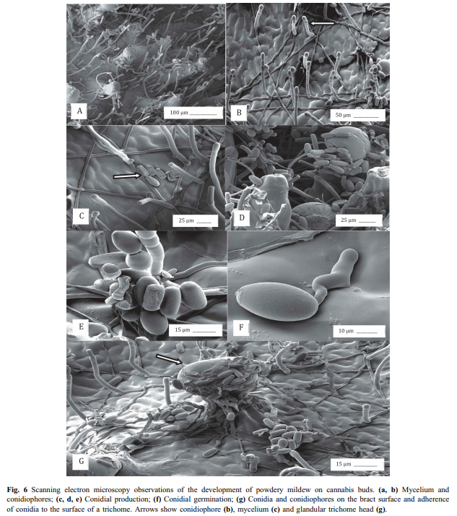
12.3 SEM of powdery mildew conidia germinating on Cannabis buds. (Punja 2018)
An occasional debate in the Cannabis industry is whether or not powdery mildews are systemic. All the peer-reviewed scientific evidence currently available, in combination with direct observation and knowledge of fungal biology, points to powdery mildew not being systemic. For a pathogen to be systemic, the pathogen would be able to infect one point on the plant (say a leaf) and then travel within the plant to infect other, distant plant parts. Powdery mildews typically form superficial infections restricted to the epidermal tissue (Fig 3). Some species are known to penetrate into the deeper palisade layers of the mesophyll. Some form localized infections into the petiole. But no powdery mildew in the entire Order Erysiphales are known to form extensive systemic infections within their respective plant host (Uwe Braun, personal communication).
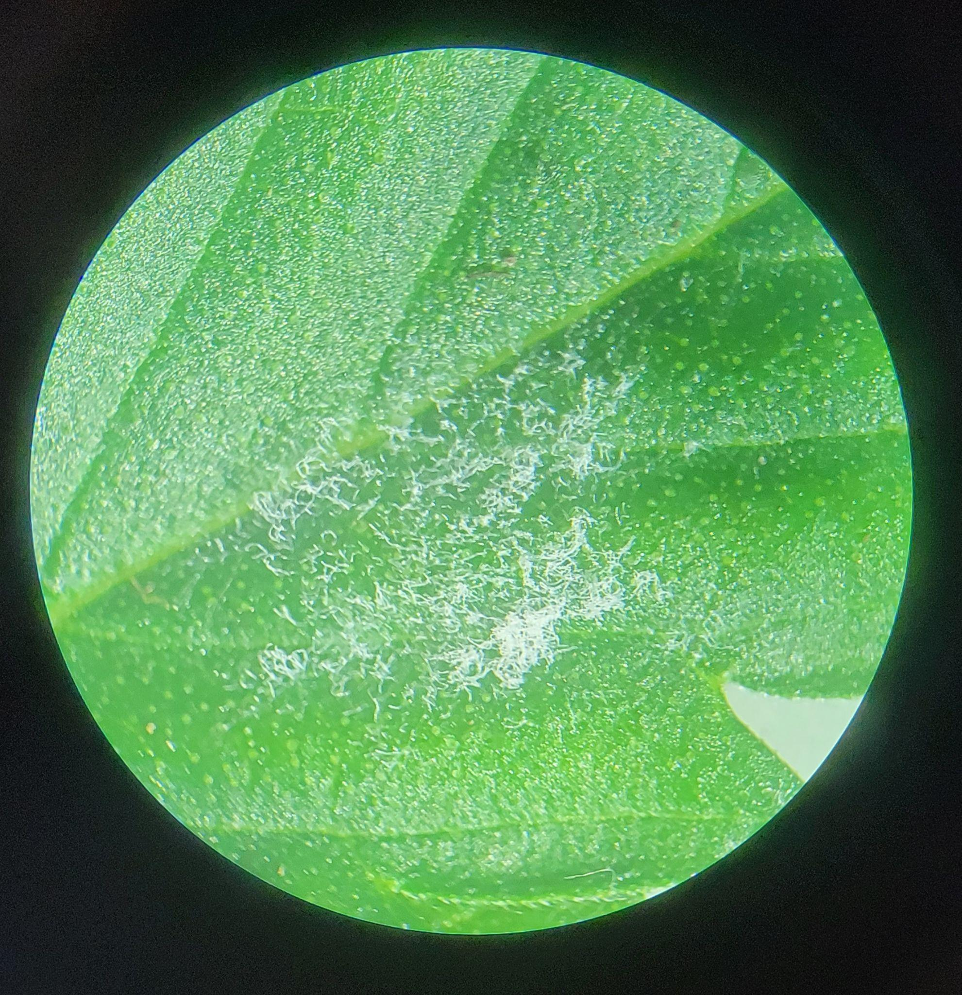
Figure 12.4. Golovinomyces ambrosiae on a Cannabis leaf (Brandon Potterdissecting scope, Cottage Grove Oregon 2021.)
Farmers often observe large outbreaks on individual plants, fail to take clean clones from plants with infection elsewhere, or experience vertical, seed borne transmission; all of these suggest systemic infection. However, powdery mildews prolifically produce spores. The spores are then wind and animal dispersed, quickly traveling from one part of a plant to another or even throughout an entire garden. Therefore, once you spot the fluffy white mass growing on a plant, the fungus has most likely already begun to produce spores and it is almost guaranteed that there are other PM spores in the air (Fig 4). Seemingly systemic infections are actually the coalescence of individual colonies, each representing a different infection point.
The fact that powdery mildew colonies almost always manifest as circular growths indicates they are individual colonies. This is analogous to fairy rings or colonies in petri dishes, which expand outward from an original inoculation point in every direction. Seed borne transmission of powdery mildew is possible, however it is exclusively (or nearly so) due to conidia on the seed surface, rather than an infection within the embryonic plant body. Because of this, seed borne infections of powdery mildew can be prevented by surface sterilizing seed prior to planting.

Biology & Life cycle
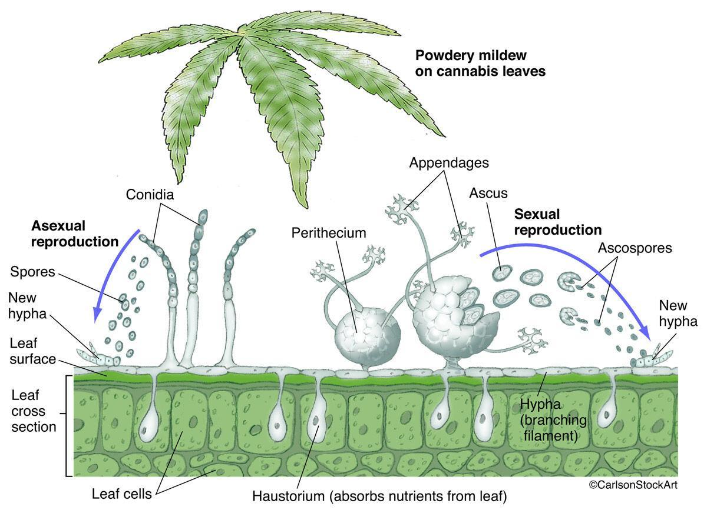
Figure 12.5 Life cycle of powdery mildew on cannabis leaf (from Carlson Stock Art…pay $299.99)

The life of a powdery mildew begins, like other ascomycete fungi, with a spore (either a sexual ascospore or an asexual conidium) (Fig. 5).When a spore lands on an area that is suitable for growth it will form a germ tube, a primary hyphae strand. The hyphae will grow from stored energy, but quickly need access to nutrients for survival.

As an obligate parasite, PM must invade host tissue in order to siphon off nutrition. In order to gain access to host tissue, a specialized structure, called an appressorium, capable of exerting high amounts of pressure onto a concentrated point on the plant surface is formed by the developing fungi (Fig. 6). Often appressoria will form above inherent weaknesses, such as directly above a stomata or at the meeting point between two epidermal cells. While a pressure peg exerts force on the leaf surface the hyphae also releases enzymes that degrade the cuticle and cell walls of the plant tissue it is trying to penetrate. If successful, the puncture peg will form a hole into the plant body through which it extends a specialized hypha termed, haustorium.
Haustoria are lobed, prong-like projections able to penetrate the cell wall of plant cells (though not the membrane). The haustorium becomes engulfed by the plant's plasma membrane, allowing the fungus to absorb nutrients from the plant in the extracellular space between the plant cell membrane and wall. A specialized, convoluted membrane is formed by the fungus within the space (called the extrahaustorial matrix) along the plant membrane in order to maximize the surface area across which it may absorb nutrients (Micali et al. 2010). The fungus now has a source of nutrients to continue to grow and mature and translocates this food throughout its entire body -including the epiphytic portions (Fig 5).
The mycelium can now form secondary hyphae which continue to spread endophytically to nearby plant cells, as well as epiphytically over the leaf surface and produce additional appresoria to create new points of invasion through which the fungus may access more areas of the plant body. After a short period of vegetative growth in a conducive environment, the fungus will produce conidiophores. Erysiphales are capable of producing conidia in great numbers.
Until recently, only the asexual state had been observed on Cannabis. Szarka et al, however, observed G. spadiceus readily forming chasmothecia in autumn on Cannabis in Kentucky (2019). Podosphera macularis is also capable of forming chasmothecia on cannabis plants (Weldon et al, 2020). Chasmothecia (or formerly, cleistothecia), are the sexual structures formed by members of the Erisyphales (Fig. 6). They appear as dark, spherical structures made of tightly interwoven hyphae with simple appendages. Inside the chasmothecia are multiple-many asci, each containing 8 ascospores (Fig. 6). Once the asci and ascospores are mature, the chasmothecium will burst and the spores will be released and dispersed into the environment.
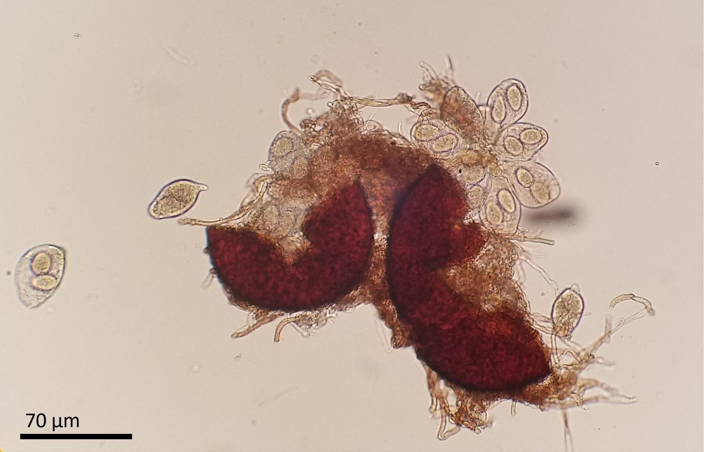
Figure 12.6 Powdery mildew chasmothecia releasing sexual ascospores. Photo credit to Dr. N. Gauthier.

The usual lack of chasmothecia on Cannabis among may indicate a biological impediment to fruiting body formation when the most common powdery mildew species infects Cannabis. If so, there may be alternate hosts on which the sexual stage of the pathogen occurs. Alternatively, these races affecting Cannabis may have lost their sexual state, or such asexual populations are isolated from compatible mating types and only exist exclusively as an anamorph locally.
This is the current state of the P. macularis population in the Pacific Northwest, where currently only the MAT1-1 type is known. Currently there is a quarantine targeting hop powdery mildew in the United States to prevent the introduction of the MAT1-2 mating type into the Northwest. The production of chasmothecia on Cannabis by P. macularis presents risk to the hop and Cannabis industries throughout the US by potentially facilitating the spread of sexual mating types into the PNW, which would be followed by a proliferation of pathovar genetic diversity (Weldon et al, 2020). Cannabis may also serve to move dangerous pathovars that are emerging in the PNW to new areas.

Powdery mildew can overwinter in the form of this resistant chasmothecia structure. Therefore PM can lay dormant in your soils or fields and then when the environment is sufficient for growth, the chasmothecia will open and release spores into the wind. If the spores land on a suitable host, the spore will germinate, a germ tube will form and the life cycle begins again (Fig. 5).

Prevention
There are a wide variety of treatments for powdery mildew, both at the store and in the literature, and everyone seems to have their own opinions on what works best at what time. The proverb that an ounce of prevention is worth a pound of treatment is especially true when it comes to fungal diseases. The best way to deal with PM is to never get it in the first place. This is accomplished by having a robust IPM program, including set scouting schedules and good cultural practices.
In general, PM species affecting Cannabis thrive in warm, humid, and poorly lit conditions. Anywhere from 60ºF to 85ºF and humidity levels above 75% can create an ideal habitat for these fungi (Amsalem et al. 2006). Additionally, variable humidity is necessary for the dissemination and subsequent germination of spores to create new infections (Dewey Scientific, Cannabis cultivation podcast 2021). Spores are able to spread during periods of low humidity and are able to germinate at high humidity. Large swings in day/night temperature and humidity can exacerbate the issue with some PM species (Mahaffee et al. 2003). Higher light intensity is also associated with reduced disease incidence, with the shaded interiors of canopies being most at risk for PM infection (Amsalem et al. 2006).
Many growers clean out the interior of canopies by defoliating and removing plant tissue, believing increased airflow will reduce powdery mildew infections. While this may actually reduce infections, the practice is likely effective due to increased light penetration, rather than or in addition to a localized reduction in canopy humidity. However, some researchers have noted that after harvesting equipment goes through the field and agitates plant biomass, disease pressure is increased (Correll et al. 1988). Regardless, maintaining a canopy with good light penetration and airflow seems to reduce PM incidence and severity.
The different species of powdery mildews will have slightly different ecological niches and may respond differently to cultural controls. As the science progresses and the species causing disease in Cannabis are better understood, more specific measures can be taken to help control PM. For instance, alternate hosts may be a significant factor in maintaining a reservoir for PM innocula. Knowing what other plant species are capable of serving as alternate hosts for the relevant PM species will greatly assist growers in keeping the local area clear of PM.
For preventative treatments, biological sprays and root drenches are recommended (Table 12.2). A strong resident microbial community, both in your soil and in the phyllosphere (area surrounding leaf surface), has been shown to increase plants’ innate resistance to pathogens. Prophylactic treatment with compost teas have been shown to effectively reduce fungal diseases under field conditions (Weltzien, 1989). The logic here is that you will be inoculating the leaf surfaces with a growing community of healthy microbes. Many endophytic microbes are able to travel from the roots into aerial plant portions, so foliar sprays are not necessarily required to cause full-plant infection. Beneficial microbes act in myriad ways to reduce PM infections.
Biological sprays could be a compost tea, a mixture of effective microorganisms, or plant fermentations (Weltzien, 1989). Commercial products are available of Bacillus subtilis, Bacillus amyloliquefaciens, Lactobacillus species, Streptomyces lydicus, and many others. Most of these commercial and naturally occurring symbionts act similarly (pathogen niche occupation, and by activating plant ISR). However, some directly antagonize disease organisms by producing antifungal compounds or acting as hyperparasites (Romero et al. 2006).
Streptomyces lydicus is an example of a microorganism that impedes powdery mildew growth through chemical defenses. This soil dwelling actinobacterium (filamentous bacterium) produces many different novel metabolites. Some of these compounds that are excreted are antifungal and antibiotic in nature, and thus are very important in the agricultural and pharmacological industries.
Natamycin is one such anti-fungal compound produced by Streptomyces lydicus (Atta et al. 2012). This compound will bind to ergosterol in the plasma membrane of fungi and inhibit protein transport, thus starving fungal cells of key nutrients and components they need to continue living eventually leading to the death of the fungus (Welscher et al. 2008). Natamycin is a broad spectrum antifungal compound and will target any fungus that contains ergosterol in the membrane (Atta et al. 2012).
Strains of Bacillus subtilis have been shown to be effective at suppressing powdery mildews as well (Shoda, 2000). This is a very competitive bacterial species that is able to persist in harsh environments through the production of spores. In addition to being able to readily colonize leaf tissue, some B. subtilis stains produce myriad antifungal compounds including surfactin, fengycin, and iturin A or bacillomycin that enable this microbe to outcompete pathogens (Romero et al. 2007).
Alternate modes of action that biocontrol agents (BCA’s) are effective at reducing powdery mildew outbreaks is through the use of fungi that parasitize the pathogen targeted for elimination. In particular, Ampelomyces quisqualis is a hyperparasite on some powdery mildew fungi. A conidial suspension is typically prepared and then applied to infected plants. Once the conidia of the hyperparasite land on the PM, A. quisqualis conidia begin to germinate and invade the host tissue. This parasite will degenerate the host (PM) tissue by extracting nutrients from the host cytoplasm, thereby starving the pathogen (Kiss et al. 2004). The conidia, hyphae and sexual spores are all subject to invasion of the hyperparasite (Kiss 2003).
Use of A. quisqualis for biocontrol is limited by the obligate nature of the hyperparasite; at least some powdery mildew must be present for A. quisqualis to establish and repeated application of conidial solutions is required, however there have been successful reports of PM control among some crops (Gadoury 1995). Further research is needed to determine the efficacy of using this biocontrol with Cannabis specifically.
A more widely proven antagonist of powdery mildew is Trichoderma harzianum (Elad et al. 1998). This BCA has several modes of fighting off pathogenic fungi. Trichoderma exhibits competition with PM for resources (food/light/space), produces antifungal compounds, acts directly as a hyperparasite of PM fungi, induces innate plant resistance, and can stimulate plant growth (Kiss et al. 2004). This BCA acts as a generalist (Naher et al. 2014), inhibiting the growth of a number of fungal pathogens.

Table 12.2. Common organic preventatives and treatments for Powdery Mildew that are acceptable for use on Cannabis. All sprays, even water, have some action by physically removing spores and hyphae from the plant surfaces.

Product | Active ingredient(s) | Mode of action
- Serenade  - Double Nickle | Bacillus subtilis  Bacillus amyloliquifaciens | - Direct competition  - Activates induced systemic resistance (ISR)
- GreenCure | Potassium bicarbonate | - Raise pH leaf surface  - Dries out mycelium due to osmotic potential
- Actinovate | Streptomyces lydicus | - Secretes antifungal compounds (natamycin)  - Direct competition
- Regalia | Raenoutria sachalinensis extract | - Activates induced systemic resistance (ISR)
- Elemental sulfur | Sulfur | - Interferes with several fungal life functions (e.g. spore germination)
- Bordeaux mixture | Copper sulfate and hydrated lime | - Copper ions inhibit spore germination, hydrated lime raises pH
- Neem Oil | Plant oils, azadirachtin and other terpenoids | - Antifungal compounds  - Physical barrier
- Dr. Zymes | Citric acid | - Unfavorable pH

Treatment
If preventative measures are not sufficient and symptoms of PM appear on leaf surfaces, there are still plenty of steps you can take to ensure minimum impact on your garden (Table 2). The first step is to manually remove infected tissue. Spray the garden down with a high pH solution or elemental sulfur (only if plants are not yet flowering) to limit spore movement and disrupt fungal growth before removing infected material. Researchers have shown that spraying the plants down, even if it is with just plain water, can reduce disease incidence (Jarvis and Slingsby 1977). Conidia do not do well when saturated in water (Perera 1972). Place infected leaves into a container and frequently disinfect your hands and shears as you perform this maintenance.
Perhaps one of the oldest treatments for powdery mildew comes from the vineyard growers of Europe (Martin, 1932). The Bordeaux mixture stems from the early 1900’s and is a mixture of copper sulfate and hydrated lime. This treatment is approved for use in organic production and is very effective at inhibiting fungal growth. The copper ion prevents conidia germination and the hydrated lime raises the pH of the leaf surface to a point that the fungus cannot tolerate (Somers, 1965). This is best used as a preventative treatment although has been shown to be effective as a contact fungicide, killing the fungus after it has gotten a foot hold.
Other common treatments include baking soda (sodium bicarbonate), potassium bicarbonate, elemental sulfur, neem oil, boron, or high silicon fertilizers (Bowen et al. 1999). There have also been reports of varying concentrations of milk being an effective treatment for the reduction of powdery mildew (Fig. 8)(Bettiol 1999, Crisp et al. 2006). Although no one is certain why milk is an effective treatment, researchers hypothesize it could be due to free radical production, antifungal fatty acid presence, or simply an osmotic imbalance (Crisp et al. 2006)
Different situations will determine which treatment will be most appropriate. For instance, you do not want to be spraying elemental sulfur on flowering plants, especially if they are destined for extraction. Doing so will result in a burnt rubber aroma (not in a good way) in the concentrated product. Using a cocktail of multiple ingredients or rotating products that have different modes of action seems to be a logical and effective way to treat infected plants. This way the fungus is less likely to develop a tolerance or resistance to any particular ingredient.
When possible, the environment of your space may be controlled to discourage PM growth. This could include raising your temperature and decreasing the relative humidity of your room, or increasing light intensity. Whole garden heat treatments (holding the garden at 100ºF for 2 hours) may reduce fungal growth (Perera, 1972). Ultraviolet light treatment systems can significantly reduce fungal inocula and subsequent disease (such as the CleanLight Pro or similar device).

In summary:
- Powdery mildew can be caused on cannabis from a number of different fungal species
- PM are typically host specific so PM on other plant species likely will not be able to infect Cannabis plants
- Environmental conditions and chemical agents can be used to decrease PM infection rates
- PM require a host plant to grow and complete lifecycle
- PM infections are superficial and not systemic

Chapter 13
Bud-rot: Botrytis cinerea and allies
Taxonomy
Kingdom: | Fungi | Fungi | Fungi | Fungi | Fungi
Phylum: | Ascomycota | Ascomycota | Ascomycota | Ascomycota | Ascomycota
Class: | Leotiomycetes | Leotiomycetes | Sordariomycetes | Sordariomycetes | Eurotiomycetes
Order: | Helotiales | Helotiales | Hypocreales | Diaporthales | Eurotiales
Family: | Sclerotiniaceae | Sclerotiniaceae | Nectriaceae | Diaporthaceae | Trichocomaceae
Genus: | Botrytis | Sclerotinia | Fusarium | Diaporthe | Aspergillus
Species: | B. cinerea,*  B. pseudocinerea, B. porri | S. sclerotiorum | F. graminearum | D. eres | A. flavus, A. niger, A. terrus, A ostianus, A. fumigatus, ect.
* Botrytis cineria, by far the most common casual organism of budrot, is the asexual stage (anamorph) of Botryotinia fuckeliana. Botryotinia fuckeliana is the corresponding name for the sexual stage (teleomorph) of the same species of fungus. Such duplicate names are the result from the historical develoment of taxonomy, when the sexual and asexual stages of the same species were thought to be different. This fungus is referred to by its anamorph (asexual) name, because the sexual state (Botryotinia fuckeliana) is rarely seen.

Introduction
Another of the infamous fungal foes well known to Cannabis growers is the bud rot causing fungus, Botrytis cinerea (Fig. 1). Also known as gray mold, bud rot begins to grow in well developed, mature flowers, capable of devastating maturing crops close to harvest. Therefore, it is important for cultivators to become acquainted with this pathogen and its lifecycle to prevent potential crop loss.
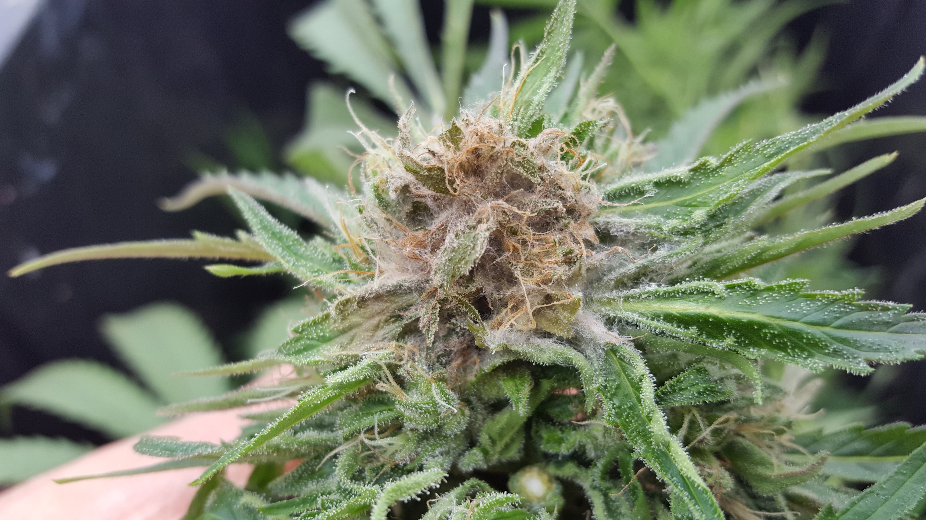
Figure 13.1. Botrytis cinerea growing on mature Cannabis flower.
Bud rot is most commonly caused by B. cinerea, though B. pseudocinere, B. porri have also been recently identified to cause disease in Cannabis (Punja and Ni 2021)(Taxonomy at beginning of chapter). Grey mold is typically first noticed by yellowing or dying back of leaf or flower tissue. Upon further inspection, one will notice white to gray cotton-like growth coupled with brittle plant material and, if the fungus has matured enough, a dust of spores being released into the wind.
Botrytis is not only feared by Cannabis growers but also by vineyard managers, strawberry growers and many other farmers (although, paradoxically, some vineyards artificially inoculate their grapes with B. cinerea to create the sweet flavors of dessert wine). Botrytis cinerea has been shown to infect over 200 species of plants, including Cannabis sativa (McPartland 1991, Williamson et al. 2007). Therefore, unlike powdery mildew, this fungus is not host specific. Also unlike powdery mildew, Botrytis is not an obligate biotroph, it is a necrotroph (Table 1). This means that this fungus does not need a living host in order to grow.
Table 13.2. Key difference between Powdery Mildew and Bud Mold
 | Powdery Mildew | Bud Mold
Scientific Name | Erisiphales: Golovinomyces cichoracearum | Botrytis cinerea
Life style | Obligate biotroph | Saprotroph/Biotrophic/Hemibiotrophic/Necrotroph
Systemic | No | Yes
Cutlurable in vitro | No | Yes
Host specificity | Host restricted | Generalist
Age of symptomatic host | All stages of plant growth | Seedling, mature inflorescence, post harvest

Botrytis cinerea (grey mold) can be a devestating pathogen, especially for crops like Cannabis. It's a classic example of a necrotrophic pathogen, meaning it kills host tissue and feeds off the remains, which allows it to thrive even on dead or senescent plant material. What stands out is the versatility and adaptability of B. cinerea in its life cycle—it’s a threat both during the plant's life cycle and after harvest, as it can colonize even cured or dried Cannabis if conditions are not optimal.
One key point is that the disease may not show symptoms during the vegetative stage, meaning that infected plants can appear healthy while harboring the pathogen. This makes B. cinerea even more challenging to manage, especially in the early stages when it can spread undetected. The fact that it can attack seedlings and even dried material underscores how important environmental control and proper post-harvest handling are for preventing outbreaks.
Your mention of B. cinerea being an "omnipresent" pathogen is crucial for anyone in the Cannabis industry. Assuming the presence of the pathogen at all times means that growers should be proactive in preventing it rather than just reactive. Prophylactic treatments and routine environmental management can go a long way toward minimizing the risk of infection.
Also, the point about increased legalization driving up spore loads and direct transmission is worth considering. As Cannabis becomes more widely cultivated, it will certainly increase the number of farms and the likelihood of spores spreading between them—whether through human activity, equipment, or even insects.
The environmental factors that favor Botrytis—such as high humidity and large temperature fluctuations—are also particularly relevant for Cannabis cultivation. These conditions are often present in controlled indoor environments if humidity is not carefully managed, or in regions with certain seasonal weather patterns, which could make B. cinerea outbreaks more likely in those areas.
The idea of developing resistant cultivars is one of the most promising long-term strategies. This could reduce the reliance on chemical treatments and make it easier to manage Botrytis naturally.

Biology & Life Cycle of Botrytis cinerea
The lifecycle of Botrytis cinerea (grey mold) begins with the release of spores (Fig. 2). These spores are typically disseminated by wind or water, though they may also be vectored by insects or arthropods. Once exposed to suitable environmental conditions, the spore germinates, forming a germ tube that develops into filamentous hyphae. Initially, the hyphae are monokaryotic, containing a single type of nucleus. As the mycelium expands, it primarily feeds on dead or necrotic tissue, but it can also establish itself as an endophyte within living plant tissues.
In addition to colonizing dead plant matter, Botrytis secretes enzymes that kill plant cells or trigger programmed cell death. It can invade seemingly healthy plant tissue through stomata or by penetrating directly through the plant’s cell wall. This mechanical penetration is facilitated by a specialized fungal structure called an appressorium. An appressorium is a modified hypha that often contains a penetration peg, allowing the fungus to breach the plant’s defenses. Botrytis may also form a multicellular appressorium, known as an infection cushion, and the hyphae feature simple porate septa, which are visible under magnification and lack clamp connections.

Infection and Colonization
Infection often begins in damaged or senescent tissue, such as a deteriorating stigma or unfertilized pistil (comprising the stigma, style, and ovary). Mechanical damage caused by herbivory or pruning also provides an entry point. Plants weakened by other pathogens or abiotic stressors (e.g., temperature, moisture) are particularly vulnerable to B. cinerea.
Botrytis can also form asymptomatic endophytic infections in otherwise healthy plants. In such cases, the plant may keep the pathogen in check, allowing the fungus to persist in a low-virulence state. However, when the plant becomes stressed or weakened, B. cinerea switches to a virulent phase, producing toxins and proteins that kill surrounding plant cells. This shift results in a unidirectional nutrient flow, with the fungus digesting and absorbing dead and dying cells, ultimately leading to further colonization. The mycelium continues to expand, destroying and overtaking more of the plant tissue, particularly in the flowers.
Evidence from various plant species, including Lactuca (lettuce) and Primula (primrose), suggests that B. cinerea may act as a latent endophyte, lying dormant until it switches to a pathogenic state (Barnes and Shaw 2002, Shaw et al., 2016). This ability to colonize healthy tissue and become virulent when conditions change highlights the pathogen's adaptability and the challenges it poses to plant health.

Seedborne Infections and Early-Stage Disease
Botrytis cinerea is often seedborne, typically found on the surface of the seed coat, although internal infestations are rare in Cannabis (du Toit et al., 2004). The fungus can kill germinating seeds and young seedlings, especially in the presence of high inoculum density or environmental stressors. Surface sterilization of seeds is effective in eliminating the majority of seedborne inocula, protecting seedlings during their critical window of susceptibility to Botrytis-induced damping-off (Sowley et al., 2010). While internal seed infections may occur, they generally do not result in significantly different disease outcomes compared to plants infected post-germination (Shaw et al., 2016). In controlled environments, however, internal seed infection could become a more significant source of disease.
Regardless of the source of infection, B. cinerea requires damaged or senescent tissue to cause disease in mature Cannabis plants. The way Cannabis inflorescences mature means that susceptible plant parts, such as aging stigmas, may be present well before harvest. These parts are prime targets for the fungus, which can actively necrotize and colonize these tissues (Fig. 3).

Endophytic and Pathogenic Relationships
Endophytic species of Botrytis, which coexist with their host in a mutualistic relationship, are often closely related to their pathogenic counterparts. Some mutualistic endophytes are even avirulent strains of otherwise harmful pathogens (Demers et al., 2015). It is possible that asymptomatic, endophytic Botrytis infections in Cannabis represent a form of mutualism under certain conditions. These infections may switch to a virulent state when environmental factors or plant stressors increase susceptibility.
Increased disease severity may, therefore, result not only from new infections but also from heightened susceptibility to necrotrophy caused by latent infections. This is especially true for plants weakened by biotic or abiotic stress, where reduced immune response allows latent Botrytis infections to progress into more severe disease.

Reproduction
Botrytis cinerea reproduces both sexually and asexually. Asexual reproduction involves the mycelium producing large numbers of clonal conidia (asexual spores) on specialized hyphal structures called conidiophores. These conidia are genetically identical to the parent mycelium, making this form of reproduction highly efficient. Botrytis can produce both macroconidia and microconidia, with conidiophore formation being less resource-intensive than the production of sexual fruiting bodies. Since conidia do not require mating, asexual reproduction is a fast and efficient means for the fungus to proliferate.
When compatible mating types are nearby, the mycelia will release signals, fuse, and exchange nuclei. The sexual state of Botrytis cinerea, known as Botryotinia fuckeliana, produces specialized fruiting bodies called apothecia. These ascocarps contain a hymenium, where ascospores are produced. When mature, the ascus bursts, releasing the spores into the wind, thereby facilitating the spread of the pathogen.
The sexual reproduction of B. cinerea occurs from sclerotia—resistant structures that help the fungus survive harsh environmental conditions. However, sexual reproduction is relatively rare in Cannabis cultivation, as apothecia formation is seldom encountered by growers.
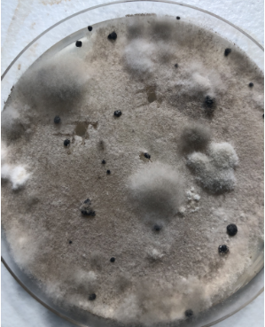
Figure 13.3. Botrytis in culture on potato dextrose agar in a petri dish. Botrytis cinerea grows first as white mycelium in culture, which discolors to gray as it produces conidia. The black structures are melanized sclerotia. Sclerotia serve as resting structures and give rise to sexual fruiting bodies, when they occur.
Botrytis cinerea can also survive and replicate through the production of chlamydospores (Jarvis, 1977). These are asexual, thick-walled resting spores, which vary in size and shape, and are formed at the terminal ends or intercalary regions of vegetative hyphae. Similar to other reproductive structures, when chlamydospores encounter suitable plant tissue, they can germinate, infect the host, and develop mycelium, eventually producing conidia.
However, in comparison to sclerotia, chlamydospores function as more temporary survival structures. They help the fungus endure short-term environmental stress or unfavorable conditions but are not as resilient or long-lived as sclerotia. While chlamydospores provide a means of survival, they are less efficient in long-term persistence and cannot sustain the fungus through extended periods of adverse conditions.

Prevention & Treatment of Botrytis cinerea in Cannabis Cultivation
Globally, Botrytis cinerea is a significant pathogen for Cannabis growers, causing severe crop losses each season. Understanding how this fungus grows, reproduces, and spreads is key to implementing effective strategies for controlling and potentially preventing infection in the first place. By proactively managing environmental factors and cultivating resistant plants, growers can significantly reduce the risk of Botrytis outbreaks.

Environmental Control
One of the first steps in preventing Botrytis is controlling the growing environment to make it less conducive for fungal growth. This includes:
- Reducing humidity late in the flowering stage, as high humidity fosters fungal development.
- Avoiding large nighttime temperature drops, which can create condensation and increase moisture levels that favor Botrytis.
- Encouraging good airflow through dense canopies to prevent stagnant, humid conditions that promote fungal growth.
By controlling these environmental factors, cultivators can make conditions less favorable for the fungus to thrive, especially during the critical flowering period.

Cultivar Resistance
Breeding cultivars with increased resistance to Botrytis is an area of active research. Cultivar susceptibility plays a significant role in disease severity, and breeding for resistance could be one of the most effective long-term strategies for reducing Botrytis-related losses. Focusing on traits like improved disease resistance or reduced plant susceptibility to necrotrophic pathogens will help growers mitigate risks.

Integrated Pest Management (IPM)
An effective Integrated Pest Management (IPM) protocol is crucial for early detection and management of Botrytis. Regular field scouting, particularly during flowering, is essential. Growers should focus on:
- Daily inspections to identify senescing leaves or any signs of fungal pathogens.
- Monitoring volatile organic compounds (VOCs) produced by plants, which can be an early indicator of Botrytisinfection. Research has shown that specific VOCs released by tomato plants can signal the presence of B. cinerea(Jansen et al., 2010). Similar techniques are being developed for Cannabis, and researchers are even exploring the use of drones to detect infection on a field scale and send real-time notifications to farmers (Garzon et al., 2019).
Until more advanced diagnostic methods are available for Cannabis, traditional scouting and early detection remain essential.

Cleanliness and Sanitation
Maintaining cleanliness on the farm is one of the simplest yet most effective strategies for preventing Botrytis infections. Removing dead leaves and unhealthy plant material helps eliminate potential food sources for the fungus (Williamson et al., 2007). Even if endophytic infections are common, the abundance of dead plant matter provides Botrytis with nutrients to thrive, overwhelming the plant and triggering necrotrophic infection.

Control of Insect Pests
Insect pests can contribute to Botrytis infections by damaging plant tissues and creating entry points for the fungus. Certain caterpillars, for example, are attracted to Cannabis inflorescences, where they tunnel into flowers, leaving behind excrement and plant debris—ideal conditions for secondary fungal infections. Botrytis quickly colonizes this damaged tissue and frass, accelerating the spread of disease.
Using biological preventatives like Bacillus thuringiensis kurstaki (Btk) can effectively reduce caterpillar damage, thereby decreasing the risk of Botrytis infection (Ignoffo et al., 1977). Integrating insect pest management into the overall IPM strategy helps mitigate the impact of Botrytis.

Seedborne Infections and Seed Treatments
Botrytis cinerea is often seedborne, and infected seedlings typically exhibit rapid decline after emergence. Once detected in seedlings, there is little that can be done to prevent its spread. To reduce the risk of seedborne infections, cultivators can surface sterilize seeds by soaking them in a 10% household bleach solution for 30 seconds (Table 2). This helps kill surface-bound spores and reduces the chance of infection during germination.
Additionally, there is some promise in seed treatments with beneficial fungi like Trichoderma (e.g., RootShield WP), which can help suppress the growth of Botrytis and other fungal pathogens (Meyer et al., 1998).

Disease Identification and Management
Botrytis cinerea is relatively easy to identify on Cannabis plants, particularly in seedlings and mature plants:
- Seedlings infected with Botrytis often die shortly after emergence, making it critical to monitor seed quality and prevent early infection.
- Mature plants can show symptoms such as wilting, gray mold growth on flower clusters, or rotting of senescing tissue, especially in humid conditions.
If Botrytis is detected in mature plants, removing infected material and improving environmental conditions can help slow the spread of the disease. However, once the fungus has established itself, there are few effective treatment options aside from chemical fungicides or biological control methods.
Managing Botrytis cinerea on Cannabis requires a combination of environmental control, vigilant monitoring, pest management, and proper sanitation. By taking a proactive approach and integrating these strategies, growers can significantly reduce the impact of Botrytis and protect their crops from this devastating pathogen.
Table 13.2. Procedure for chemical and biological treatment of contaminated seeds.
Seed treatment options
Chemical | Biological
- Make a 10% bleach solution by adding 10 mL of household bleach to 90 mL of water.  - Put seeds in a small jar  - Pour bleach solution over seeds  - Swirl around for 30 seconds  - Empty bleach solution while keeping seeds in the jar  - Pour water into jar and swirl for 30 secs  - Empty water from seeds and repeat 2x times with water  - Directly sow into growing medium | - Prepare a spore suspension by purchasing a product containing the organism you want to coat seeds with.  - Place seeds to be treated in spore suspension and swirl for 1-2 minutes  - Remove seeds from spore suspension  - Directly sow seeds into growing medium

Treating Botrytis cinerea infections on Cannabis flowers presents unique challenges, as most growers prefer not to apply sprays directly to flowers during the flowering phase. Therefore, a combination of preventative measures, environmental control, and resistant genetics is essential to protect plants from this fungal pathogen.

Preventative Strategies
One of the most effective ways to manage Botrytis is by preventing the fungus from taking hold in the first place. Here are some key strategies:
- Preventative Sprays: While many growers avoid spraying flowers directly, preventative treatments can be useful in the early stages of growth. These treatments are usually applied before flowers form, and typically include fungicides or biological control agents. Early intervention can help minimize the likelihood of infection later on.
- Resistant Genetics: Growing Cannabis cultivars with inherent resistance to Botrytis is a promising long-term strategy. Breeding for genetic resistance can significantly reduce the need for chemical treatments and increase overall crop health, especially in environments prone to fungal pressure.

Environmental Control
Maintaining optimal environmental conditions is critical in preventing Botrytis outbreaks. This pathogen thrives in certain conditions, but there are several factors growers can manipulate to reduce its impact:
- Humidity Control: Botrytis thrives in humid conditions, particularly with relative humidity (RH) levels above 60%. However, it struggles to survive in dry conditions. Research has shown that maintaining a humidity level below 45% RH is ideal for preventing Botrytis growth (Prins et al., 2000). While this humidity level may be lower than what's optimal for Cannabis growth, maintaining a balance between humidity control and the needs of the plant is essential. Reducing humidity late in the flowering stage, when the risk of infection is highest, can prevent fungal colonization.
- Airflow: Adequate airflow is crucial for reducing fungal pressure. Both horizontal and vertical air movement help prevent the accumulation of moisture and reduce the likelihood of spores settling on plant tissue (Elad, 2015). Ensuring good circulation throughout the canopy can make the environment less hospitable for the fungus.
- Light: Botrytis does not thrive under high light conditions. In fact, the conidia (spores) of Botrytis can only survive for a few minutes under intense sunlight, such as midday in Israel (Rotem & Aust, 1991). This highlights the importance of light management in Cannabis cultivation. Providing even light distribution and ensuring that the plants receive an appropriate amount of light can help deter fungal growth. However, this may not be foolproof, as Botrytis can still infect plants grown outdoors under direct sunlight, especially in regions like Southern Oregon or Northern California.

Managing Infected Flowers
Once Botrytis has taken hold on the flowers, immediate action is necessary, though it is important to note that the fungus is often already widespread in the environment at this point. Some growers attempt to remove infected sections of flowers to prevent further spread, but this approach has limitations:
- Removing Infected Flowers: Cutting away infected parts of the flower may slow down the spread of the disease locally, but it doesn't address the broader environmental presence of Botrytis spores. Even if visible fungal growth is removed, spores may still be present in the air, continuing to pose a risk. If endophytic infections (internal, symptomless infections) are responsible for the outbreak, cutting out affected tissue might not be effective at all.
- Spore Containment: If you do decide to remove infected tissue, it is important to minimize spore dispersal. Immediately place the cut flowers in a plastic bag to contain the spores and reduce the spread. Also, be sure to disinfect scissors or any tools used for cutting with isopropyl alcohol to prevent cross-contamination.

Biocontrol and Pest Management
Utilizing biocontrol agents can help reduce secondary infections caused by insect vectors. Insects, such as caterpillars, often damage Cannabis flowers and create an ideal environment for Botrytis to colonize. By controlling these pests, growers can reduce the likelihood of secondary fungal infections. Biological agents like Bacillus thuringiensis kurstaki(Btk) can effectively target caterpillars, reducing their numbers and subsequently decreasing the risk of Botrytis outbreaks (Ignoffo et al., 1977).
Table 13.3. Fungicidal products effective against B. cinerea.
Product | Active ingredient(s) | Mode of action
- Serenade  - Cease | Bacillus subtilus | - Direct competition  - Activates induce plant resistance (ISR)
- ZeroTolerance  - Method1  - Essential oils | Thyme oil, peppermint oil, rosemary oil, clove oil, garlic oil, sesame oil | - All have varying degrees of antifungal properties
- Nuke ‘em  - Dr. Zyme | Citric acid (maybe other active ingredients) | - Citric acid has some antifungal properties, but it varies fungus to fungus and is usually not very effective
- Oxidate 2.0  - Zerotol 2.0  - Jet-AG | Hydrogen dioxide, Peroxyacetic acid | - Oxidizing agent that destroys cell membranes and DNA
- Botector | Aureobasidium pullulans | - Direct competition for space

Biocontrol of Botrytis cinerea in Cannabis Cultivation
Biocontrol of Botrytis cinerea offers a natural and sustainable approach to managing this widespread and damaging pathogen in Cannabis cultivation. Fungal antagonists like Aureobasidium pullulans, Ulocladium atrum, Gliocladium roseum, and Trichoderma harzianum hold significant potential for reducing Botrytis infections, especially when applied early in the plant's life cycle. With continued research and refinement of application methods, these biocontrol agents could become an essential part of integrated disease management for Cannabis, providing growers with an effective, environmentally friendly alternative to chemical treatments.
Biocontrol agents (BCAs) offer a promising alternative to chemical treatments for managing Botrytis cinerea (B. cinerea), especially in the context of Cannabis cultivation. By using naturally occurring fungi and bacteria, growers can combat this destructive pathogen without the drawbacks of synthetic pesticides, such as resistance development or residue concerns.
One of the most studied biocontrol agents for Botrytis cinerea is the Ascomycete fungus Aureobasidium pullulans. This microorganism has demonstrated the ability to outcompete Botrytis for space and resources, essentially preventing the pathogen from establishing itself on plant surfaces. A. pullulans works through a combination of mechanisms, including competition for nutrients and space, as well as the production of antifungal metabolites that inhibit Botrytis growth.
In a study by Trapman et al. (2010), the combination of A. pullulans and hot water treatments effectively reduced post-harvest contamination of several fungal pathogens, including Botrytis cinerea, in multiple crops. This dual approach shows promise in Cannabis cultivation, where post-harvest contamination is a significant concern. By applying A. pullulans as part of an integrated pest management strategy, growers can limit the spread of gray mold, particularly in a post-harvest environment.
Another potential biocontrol agent for Botrytis cinerea in Cannabis is the fungus Ulocladium atrum. This antagonistic fungus has shown effectiveness in controlling Botrytis in other crops, such as strawberries. In trials, Boff et al. (2002) found that applying U. atrum early in the plant's growth cycle resulted in better disease control than applications made only once the plants started flowering. This suggests that early intervention is key for maximizing the effectiveness of U. atrum in preventing Botrytis outbreaks in Cannabis as well.
Additional studies, such as those by Kohl et al. (1998), have demonstrated that U. atrum can significantly reduce the sporulation of Botrytis cinerea and mitigate crop loss when applied in the early stages of plant development. For Cannabis, early applications of U. atrum could be integrated into the cultivation cycle to preemptively address Botrytis risk before it becomes a problem during flowering.

In addition to A. pullulans and U. atrum, several other fungi show potential as BCAs against Botrytis cinerea. Gliocladium roseum and Trichoderma harzianum have both been identified as effective antagonists of Botrytis in other agricultural systems (Sutton et al., 1997; De Meyer et al., 1998). These fungi employ various mechanisms to suppress Botrytis, including the production of enzymes that break down fungal cell walls and the secretion of volatile compounds that inhibit pathogen growth.
Both Gliocladium roseum and Trichoderma harzianum are well-studied for their biocontrol properties in a variety of crops, and further research could help determine their specific efficacy in Cannabis cultivation. Given their wide range of action and their natural occurrence in the environment, these fungi could serve as effective, eco-friendly alternatives to traditional fungicides.

Future Research Directions
While several biocontrol agents have shown promise in combating Botrytis cinerea, more research is needed to determine their optimal application methods, efficacy in Cannabis, and compatibility with other cultivation practices. Increased research into fungal antagonists, their interactions with plant hosts, and their potential for large-scale application will likely lead to the development of more tailored biocontrol strategies for Cannabis growers.
Additionally, exploring the synergy between different BCAs and integrating them into existing Integrated Pest Management (IPM) protocols will provide more robust and sustainable solutions for managing Botrytis in Cannabis cultivation.
In summary:
- Bud rot is another fungal disease caused by a number of different fungal species, most noteably Botrytis cinerea
- Unlike PM, bud rot is not an obligate pathogen so does not require a host plant to grow and the same fungal species can infect a wide range of host plants
- Botrytis species have been found to be endophytes in asymptomatic Cannabis crops
- There are a number of treatment options for controlling this fungal

Ch 14
Damping off

Taxonomy | Rhizoctonia | Botrytis | Fusarium | Pythium | Macrophomina
Kingdom | Fungi | Fungi | Fungi | Chromista | Fungi
Phylum | Basidiomycota | Ascomycota | Ascomycota | Heterokontophyta | Ascomycota
Class | Agaricomycetes | Leotiomycetes | Sordariomycetes | Oomycota | Dothideomycetes
Order | Cantharellales | Helotiales | Hypocreales | Peronosporales | Botryosphaeriales
Family | Ceratobasidiaceae | Sclerotiniaceae | Nectriaceae | Pythiaceae | Botryosphaeriaceae
Genus | Rhizoctonia | Botrytis | Fusarium | Pythium | Macrophomina
Species | R. solani | B. cinerea | F. solani, F. oxysporum, F. sulphurem, F. avenaceum, F. graminearum | P. aphanidermatum, P. ultimum, P. myriotylym | M. phaseolina

Introduction
Damping off, often incorrectly called dampening off, is common on many horticultural plants. The term is used to classify diseases caused by multiple fungi that mainly affect plants in the seedling stage. Typically, damping off (DO) kills the plant before or shortly after the seed germinates or on unrooted/newly rooted cuttings. Damping off does occur in Cannabis gardens and understanding this disease will help alleviate growers from losing immature plants.
Plants that are infected with these fungi may germinate and emerge from the soil but within a few days they are weakened by the fungus growing on the stem or root tissue. Often, the pathogen will infect the stem right where it emerges from the soil (post-emergent). This results in plants that are wilted and falling over. However, DO pathogens can also cause pre-emergent disease as well, preventing seedling from ever emerging from the soil (Neher et al. 1987).
Once you see that a plant has fallen victim to damping off, it is typically too late to act. Plants that are infected with these fungi usually will be too damaged to recover after the symptoms are observed. The same damping off fungi can infect a number of host plants, making the fungi that cause DO generalists. This is similar to the bud rot causing fungus, B. cinerea, which itself can cause damping off in seedlings (Darvas et al. 1978).
Thankfully, this disease is mainly restricted to seedlings or young plants. As seedlings mature they express more resistance traits, including production of secondary metabolites and increased structural defense. Damping off is a particularly high risk for hemp fields, where farmers are directly sowing a large number of seeds into soil (Gibson 1956). If the soil is too cold and wet or other conditions favorable for the fungus, the pathogen can grow and infect the farmers' hard work (Yitbarek et al. 1988). Spores of the fungus could be waiting in the medium that the seed is planted into, on the seed coat itself, or blown in by the wind.
The presence of a pathogen in a particular soil does not necessarily lead to plant infection, although some researchers have observed that inoculum levels can be directly correlated with infection rates (Yitbarek et al., 1988). Neher et al. noted that environmental factors, the virulence of pathogens, and the susceptibility of the host all influence disease severity and mortality rates.
Studies have also shown that the diversity of the microbial community in soil can significantly reduce infection rates (Ross et al., 2019). In the future, microbial consortia may prove to be more effective biocontrol agents (BCAs) than single-species products. Microbial teas and compost applications can increase microbial diversity, though they are unselective with respect to species. On the other hand, single-species products containing known antagonists may be more effective when combined with other products.
While fungi can cause this disease, it may also be caused by Oomycetes, or water molds, which are not true fungi. Originally classified as fungi based on their morphology, water molds have since been reclassified to the phylum Heterokonta (protists) based on ancestry, placing them as close relatives of photosynthetic algae.
Most water molds act as parasites or pathogens. As mentioned earlier, the great Irish potato famine was caused by a water mold from the genus Phytophthora. Interestingly, no species of Phytophthora are known to infect Cannabis, including the generalist P. cinnamomi (at least not yet identified to do so). In fact, Cannabis is even recommended as a rotation crop to control Phytophthora (Israel, 1981). On the other hand, Pythium, another Oomycete, is a common cause of damping off in Cannabis.
A key distinction between water molds and fungi is that water molds produce mobile asexual zoospores, which can actively disperse in water. As a result, damp, waterlogged soils with low oxygen levels create optimal conditions for these pathogens to thrive, particularly when a susceptible host is planted nearby.
Biology & Life Cycle
Fungi
A wide range of fungal species cause damping-off disease across various plant species. Many of these fungal pathogens can infect Cannabis plants. Rhizoctonia solani, a generalist pathogen capable of infecting a broad variety of host plants, is commonly found in important food crops such as radish (Henis et al., 1978), soybean, tomato, rice, potato, alfalfa, and more (Anderson, 1982), including Cannabis sativa (McPartland and Nicholson, 2003).
Rhizoctonia solani is the asexual name for the basidiomycete fungus, with its sexual state (teleomorph) being Thanatephorus cucumeris. Anderson (1982) explains that R. solani is not a single species but a species complex, making its study and control challenging.
The fungus produces haploid basidiospores, which germinate and are capable of producing asexual conidia. Rhizoctoniacan also form microsclerotia (Anderson, 1982). It is a facultative pathogen, able to survive on dead material, and can be grown and sexually mated in vitro (Carling et al., 1987).
Other damping-off fungi belong to the phylum Ascomycota, including the genera Fusarium, Botrytis, and Macrophomina. Bloomberg (1978) noted that temperature was the most significant environmental factor influencing disease incidence caused by damping-off fungi. The biology of most of these fungi is discussed elsewhere in this book. It's important to note that species of both Botrytis and Macrophomina readily form sclerotia, which may serve as a distinguishing feature for farmers or agronomists. Fusarium species can also produce chlamydospores, which serve as resting structures that allow the fungus to survive in harsh environments for extended periods.
Oomycota
Water molds share some superficial similarities with fungi, such as filamentous growth and the presence of cell walls (Table 1). However, the materials that comprise the cell walls of Oomycetes are cellulose and beta-glucans, rather than chitin, which is found in fungi. Additionally, water mold spores (zoospores) have two flagella, which help them move and navigate through liquid substrates. The only true fungi that possess flagella are the chytrid zoospores, which have a single posterior flagellum.
Oomycete hyphae are coenocytic (aseptate), which is why some people caution farmers to watch out for hyphae without septa when inspecting soil or root samples under the microscope. However, not all aseptate fungi are harmful (e.g., the mycorrhizal Glomeromycota and many harmless saprophytic Zygomycota), and not all septate fungi are beneficial (most fungal pathogens are septate). Though these organisms are related to algae, they have lost the ability to perform photosynthesis.
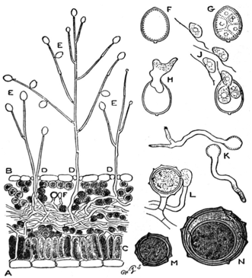
Figure 14.1. A) Leaf cross-section of Pytopthora infestans hyphae growing through leaf tissue, B) P. infestans sporophores sprouting through stomata. C) Palisade mesophyll layer of leaf D) Under (abaxial) side of leaf E) Sporangia hold zoospores F,G,H) Sporangium development J) Mobile zoospores K) Germinating zoospores L) Antheridium and Oogonium fusion M,N) Development of oospore (wikisource).

Oomycetes like Pythium have a complex life cycle with various forms and growth patterns. The life cycle of water molds begins, much like fungi, with a spore. Upon landing on a suitable growth substrate, such as plant tissue, the spore germinates and begins to grow hyphae. Similar to fungi, Pythium accesses host tissue by developing an appressorium, releasing extracellular enzymes that facilitate the damage and penetration of host tissue. The hyphae then invade the host tissue and siphon nutrients, fueling the growth of the oomycete (Fig. 1).
Water molds are typically transmitted through water and have even been found in some irrigation systems (Ali-Shtayeh et al., 1991). Therefore, eliminating stagnant or standing water in or near fields can help reduce the risk of harboring pathogens in close proximity to crops. Once a field is infected, the zoospores of the fungus can encyst in a dormant state. When environmental conditions become favorable again, the cysts can germinate and reinfect plants. This makes soil remediation challenging once it has been contaminated by these organisms.
Prevention & Treatment
The treatment of damping-off depends on the specific disease organism, its location (seed vs. soil), and environmental conditions. As always, prevention is the most effective approach to managing damping-off disease. For seed planting, various seed coat treatments can be applied directly to the seeds. Seeds can be pretreated with organisms antagonistic to damping-off, such as Trichoderma products (e.g., Rootshield WP), or surface sterilized with a dilute bleach solution or alcohol (Lifshitz et al., 1986; Wenny and Dumroese, 1987).
The use of biocontrol agents (BCAs) in agriculture is becoming increasingly popular due to the rising resistance to chemical pesticides and growing concerns about the potential damage some chemicals can cause to soils and humans (Coninck et al., 2020). Many Trichoderma species used as BCAs act as mycoparasites to certain damping-off organisms, parasitizing the plant pathogen directly while also promoting the production of plant growth-promoting compounds (Bedine Boat et al., 2019).
Treatments can also be applied to the growing medium prior to planting, becoming less necessary as the seedlings mature. When starting seeds in pots, the growing medium can be pasteurized to eliminate potential disease organisms (Warcup and Baker, 1963). Steam sterilization may also be used to treat large areas of soil on both field and greenhouse scales. However, steam sterilization is more accurately described as pasteurization, as it does not kill all life in the soil. Specific temperature ranges and treatment times can kill pathogenic species while preserving beneficial organisms (Tanaka et al., 2003). Beneficial organisms can also be selectively inoculated into treated soil.
Rotating crops in contaminated soil can help reduce the population of damping-off species, particularly if Brassicas are used in the rotation and crop residue is incorporated post-harvest (Njoroge et al., 2009) (see Chapter 22, “Soil Treatments”). Growing crops that the pathogen cannot infect forces the pathogen to compete solely as a saprophyte, where it must compete with other aggressive microorganisms. Rotating crops until no sign of damping-off remains may be a long-term method of eradicating these pathogens from a field (Cheah et al., 2008).
It’s important to avoid over-watering seedlings and to prevent them from germinating in cool, damp conditions. Using a seedling heat mat indoors can help address this issue. Outdoors, make sure to plant seeds only after the last frost in your area. Clean all equipment prior to planting, and ensure the soil is as healthy as possible. Providing adequate airflow and temperature is also essential for germination, as this reduces the chance of pathogen growth while stimulating healthy plant growth. Lastly, always use high-quality genetics to ensure the best chance of success.
In summary:
- Damping off is a catch-all term for fungal pathogens that usually infect seedling growth but can occur in more mature plants as well
- This systemic infection blocks vascular tissue of the plant from transporting nutrients throughout the plant body
- Common reservoirs for DO fungi can be the seed coat, the soil/potting medium, or air-borne spores
- This disease is difficult to combat after symptoms are observed on plants

Ch 15
Crown-rots & Wilts

Of the fungal pathogens that infect commercial cash crops, none are more devastating than those caused by vascular wilts. Wilting occurs when plants lose turgor pressure in their cells due to a lack of water, which can be triggered by either abiotic or biotic factors (Fig. 1), ultimately leading to total crop failure. Vascular wilt is a general term used to describe the symptom caused by various disease organisms that block the vascular tissue in plants, thereby restricting the flow of water from the roots to other parts of the plant. This chapter will focus on fungal pathogens that are known to cause wilting in Cannabis plants.
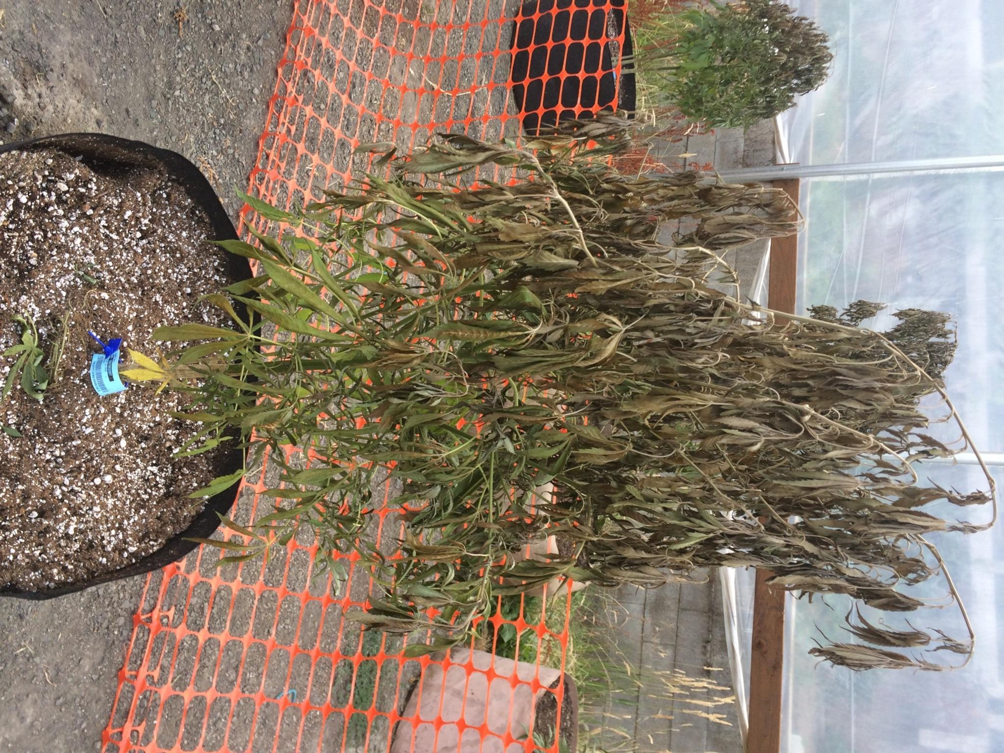
Figure 15.1. Cannabis plant severely affected by Fusarium wilt caused by a Fusarium species.
Vascular wilts are most commonly a concern for large-scale outdoor cultivators. Fusarium is a genus of soil-borne fungi that can cause extensive damage to a wide variety of plants. In particular, Fusarium oxysporum is known to cause wilt in Cannabis. Fusarium is most frequently identified in hemp fields, though this may be due to the widespread cultivation of hemp, which increases the likelihood of encountering this pathogen. Fusarium diseases might also be more prevalent than commonly recognized, as many individuals are unfamiliar with the symptoms and appearance of this pathogen.
Some of the organisms that cause Fusarium wilt in Cannabis can also infect other host plants, so it is important to be aware of the plants growing near Cannabis to minimize the risk of unintentional contamination. Other hosts include coffee, tobacco, alfalfa, and soybeans. Given the rapid spread of these fungi, early identification of the disease is critical for effective management.
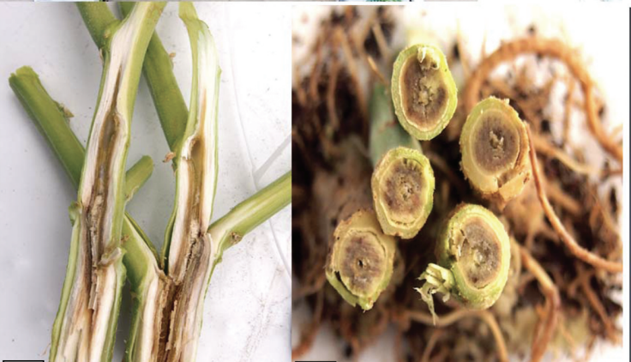

Figure 15.2. Cannabis stalks infected with Fusarium proliferatum which blocks movement of water and nutrients through the vascular system of the plant. (Punja 2020)
of water and nutrients through the vascular system of the plant (Punja 2020).
Symptoms of Fusarium infection are typically characterized by overall wilting of the plant. If the fungus is causing "foot rot," the stems near the soil line may develop a brownish appearance (Fig. 2). Spots will first appear on the lower, more mature leaves. These spots will develop between the leaf veins and spread quickly to newer tissue. Eventually, the leaf tips will curl upward, and the plant will succumb to wilting. Thus, the traditional classification of Fusarium wilt aptly describes the progression of this disease.
In addition to malicious introductions, Fusarium may naturally occur in a region's soil or be dispersed into a garden via wind-borne spores, imported soil, transplant rootballs, or by human activity and equipment. Regardless of its origin, certain environmental conditions promote Fusarium growth, allowing this pathogen to proliferate at an alarming rate.
Punja and Rodriguez (2018) demonstrated that Fusarium oxysporum and F. solani can infect Cannabis roots in a hydroponic system. While infected plants did not always exhibit wilting symptoms, they did show stunted root growth and development. They also noted that plants grown in soil systems exposed to the pathogen were more likely to display typical wilt symptoms. This is due to the more challenging environment for roots to access nutrients, compared to plants grown hydroponically.
Biology & Lifecycle
Fusarium
Fusarium species, classified in the phylum Ascomycota, are soil-borne fungi that produce both sexual and asexual spores. The sexual fruiting body, a structure called a perithecium, and abundant conidia are formed, enabling the fungus to spread and persist. Fusarium can grow saprophytically on dead material and become pathogenic when it encounters a suitable host, such as Cannabis.
Lifecycle:
Fusarium begins its lifecycle with sexual spores or conidia. When a host plant is detected, the fungus grows toward the roots, forming an appressorium to access host tissue. Fusarium invades the xylem, the tissue responsible for water transport, restricting water flow and causing wilting. The fungus produces microconidia that spread via sap flow through the xylem, allowing further colonization of the plant. Fusarium thrives in warm temperatures, with symptoms often appearing once temperatures exceed 26°C (~78°F).
Symptoms:
Fusarium wilt presents as general wilting, with brown discoloration at the soil line, especially in cases of "foot rot." Lower leaves show spots that spread to newer tissue, followed by leaf curling before the plant wilts completely.
Prevention & Treatment:
- Avoid wet, poorly-drained areas to minimize Fusarium growth.
- Excess or insufficient nitrogen fertilization can encourage Fusarium infestation.
- Fusarium requires oxygen to survive, so compact, anaerobic soils are unsuitable for its growth.
- Infected plants should be removed immediately and destroyed (e.g., burning plant debris) to prevent further spread.
- Movement of infected materials, such as soil on equipment or shoes, can carry the pathogen across fields, increasing contamination.
Verticillium:
Verticillium dahliae and V. albo-atrum are also known to cause wilt in Cannabis plants. Verticillium wilt, like Fusarium wilt, is a systemic disease that affects water transport via the xylem, causing wilting. Symptoms include yellowing and wilting leaves, as well as a reddish-brown discoloration in the xylem tissue when the stem is cut.
Verticillium is a genus of soil-borne Ascomycete fungi that can infect Cannabis plants, typically entering through the roots. The fungus is primarily found in soils as microsclerotia (specialized resting structures) or dark hyphae. These structures germinate in response to root exudates and grow toward the plant's root cells. Once inside, the fungus travels through the plant’s vascular system (the xylem), a tissue responsible for water transport, causing the characteristic wilting by blocking the xylem.
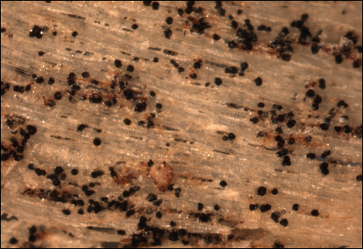
Figure 15.5. Verticillium microsclerotia embedded in woody tissue of Acer spp. Photo credit to N. Brazee

Verticillium spreads through mycelium, conidia, or microsclerotia. When blocked in the xylem, the fungus forms new mycelium around the obstruction, digesting plant tissue and continuing its spread. The fungus proliferates quickly inside the xylem, using conidia for faster dispersal.
After the plant dies, Verticillium acts as a saprotroph, decomposing the dead tissue. The fungus then forms resting structures (microsclerotia or melanized hyphae) within the dead plant’s vascular tissue, allowing it to survive in the soil until the right conditions and host are available. Verticillium dahliae forms more durable microsclerotia and persists in harsh environments longer than V. albo-atrum, which forms less resilient dark hyphal cells.
Prevention and Treatment:
Remediating soil infected with Verticillium is challenging. Traditional chemical treatments, like soil fumigation with Methyl Bromide and Chloropicrin, can reduce pathogen populations but destroy soil health and biodiversity, making it a less desirable solution. Methyl Bromide is highly toxic and can only be used under specific exemptions granted by the EPA.
To manage Verticillium, growers should prioritize good agricultural practices, focusing on soil health and cleanliness. Regular applications of high-quality, biologically active compost can help introduce beneficial microorganisms that protect plants from pathogens. Additionally, planting or breeding resistant Cannabis cultivars can significantly reduce the impact of Verticillium wilt, minimizing crop loss.

Verticillium vs. Fusarium:
- Both wilts have similar symptoms, but Verticillium wilt may also show a "tiger stripe" pattern in leaves.
- Microsclerotia or conidia are often found in the xylem when examined under a microscope.
- Verticillium dahliae is more persistent in soil and affects a wide range of plants like cotton, tomato, and eggplant, while V. albo-atrum has fewer host plants, including hops, a close relative of Cannabis.
Identification and Prevention:
- Accurate identification of Verticillium requires microscopic or molecular techniques.
- Similar prevention methods to Fusarium can be applied, including careful soil management and avoiding contamination from infected plant materials.
Macrophomina
Macrophomina phaseolina, commonly known as charcoal rot, is an Ascomycete fungus responsible for various crop diseases, including vascular wilts. It has an exceptionally broad host range, capable of infecting over 500 different plant species, including Cannabis (Khan, 2007). This pathogen is notorious for causing multiple diseases such as damping off, basal stem rot, root rot, and seedling blight (Ijaz, 2013). While symptoms often resemble other wilt diseases, M. phaseolina can remain latent, only presenting symptoms later in the plant's life (Ijaz, 2013). Notable signs include reduced emergence, severe wilting, yellowing leaves, necrosis, and a general loss of vigor (Kunwar et al., 1986).
A distinct symptom of this infection is the presence of tiny black, tuber-like structures, known as microsclerotia, formed by the fungus, which can be found when the plant stem’s epidermis is peeled off. M. phaseolina is transmitted via soil, roots of transplanted plants, or seed coats (Khan, 2007). Moreover, this fungus poses a potential health risk to humans, particularly immunocompromised individuals (Srinivasan et al., 2009).
Biology & Lifecycle
The lifecycle of M. phaseolina begins with the production of microsclerotia, small, melanized, protective structures that allow the fungus to survive harsh conditions for extended periods (Meyer et al., 1974). These microsclerotia can persist in soil for 2-15 years. When a susceptible plant releases root exudates, the microsclerotia germinate, and the fungus invades the roots.
Once inside the plant, M. phaseolina primarily occupies the intercellular spaces of the root cortex cells (Gupta et al., 2012). Unlike other wilt-causing organisms, it affects the fibrovascular system of the plant, not just the xylem. The fungus can travel through the vascular system, often clogging the tissues, depriving the plant of water and nutrients. This leads to the characteristic "charcoal rot" symptom – black/grey mold in the vascular system.
As the plant dies, M. phaseolina can act as a saprotroph, breaking down dead tissue and leaving behind microsclerotia in the soil, awaiting the next susceptible crop. M. phaseolina produces pycnidia, which are fruiting bodies that house ascospores. These are released when the sacs burst, but they only form under specific conditions, either in certain hosts or in vitro (Gupta et al., 2012, Gaetán et al., 2006).
Prevention and Treatment
Managing charcoal rot is challenging due to the fungus’s persistence in soil. Microsclerotia can survive for long periods, and soil fumigation, though effective, is not always desirable due to its environmental impact (Duniway, 2002). Non-chemical methods, such as crop rotation, soil solarization, and organic amendments that alter the C:N ratio, are recommended (Israel et al., 2005). Maintaining soil health and cleanliness is crucial in preventing the spread of the pathogen.
In cases where M. phaseolina has already infected the field, it is essential to remove infected plants promptly to avoid further contamination. Although chemical antifungals can control the pathogen, their use is controversial due to the broad environmental consequences, and they should only be considered as a last resort.
Developing resistant crop varieties through breeding programs will ultimately reduce yield loss caused by this pathogen, though this will require time and investment in research and development. While M. phaseolina poses a significant challenge to crop health, especially in fields where it persists, practicing good farm management, including crop rotation, soil health improvement, and the cautious use of chemical treatments, can help mitigate its impact.
Athelia rolfsii (formerly Sclerotium rolfsii)
Athelia rolfsii, formerly known as Sclerotium rolfsii, is a particularly damaging fungus that affects Cannabis and many other plant species. The pathogen was initially discovered on a diseased tomato plant in Florida, and it was originally named Sclerotium rolfsii. However, molecular research revealed its sexual stage, leading to its reclassification as Athelia rolfsii. The common name "Southern Blight" stems from its preference for warm climates and its initial discovery in the southern United States.
Athelia rolfsii is a facultative pathogen, meaning it can survive and grow on dead organic matter (acting as a soil saprotroph) when no host plants are present. However, when a susceptible host is available, it infects plants at various stages of growth, causing different symptoms based on the plant's development. For seedlings, it can cause damping-off, whereas for mature plants, it results in wilting or blighting, particularly in the crown or lower stem area. The fungus also produces sclerotia, which helps it survive under harsh environmental conditions, making it difficult to eliminate from infected fields.
Biology & Lifecycle
Athelia rolfsii is a Basidiomycete, making it more distantly related to many other common Cannabis pathogens, which are typically Ascomycetes. The fungus survives in the soil as sclerotia (hard, melanized structures) and vegetative hyphae. The sclerotia can persist in the soil for extended periods, sometimes up to five years, depending on the environmental conditions (Menzies, 1983). These sclerotia germinate when favorable conditions arise, particularly when susceptible plants release root exudates.

Upon germination, the fungus infects plants via direct contact between its hyphae and the roots. The hyphae secrete enzymes that break down plant cell walls before penetrating the cells. Although A. rolfsii is not a systemic pathogen, it causes local lesions at the soil line, which can girdle the stem, kill the root system, and ultimately lead to the death of the plant. Crown rot is a common symptom, where lesions appear on the stem near the soil surface, and white mycelium can be observed growing around the base of the plant.
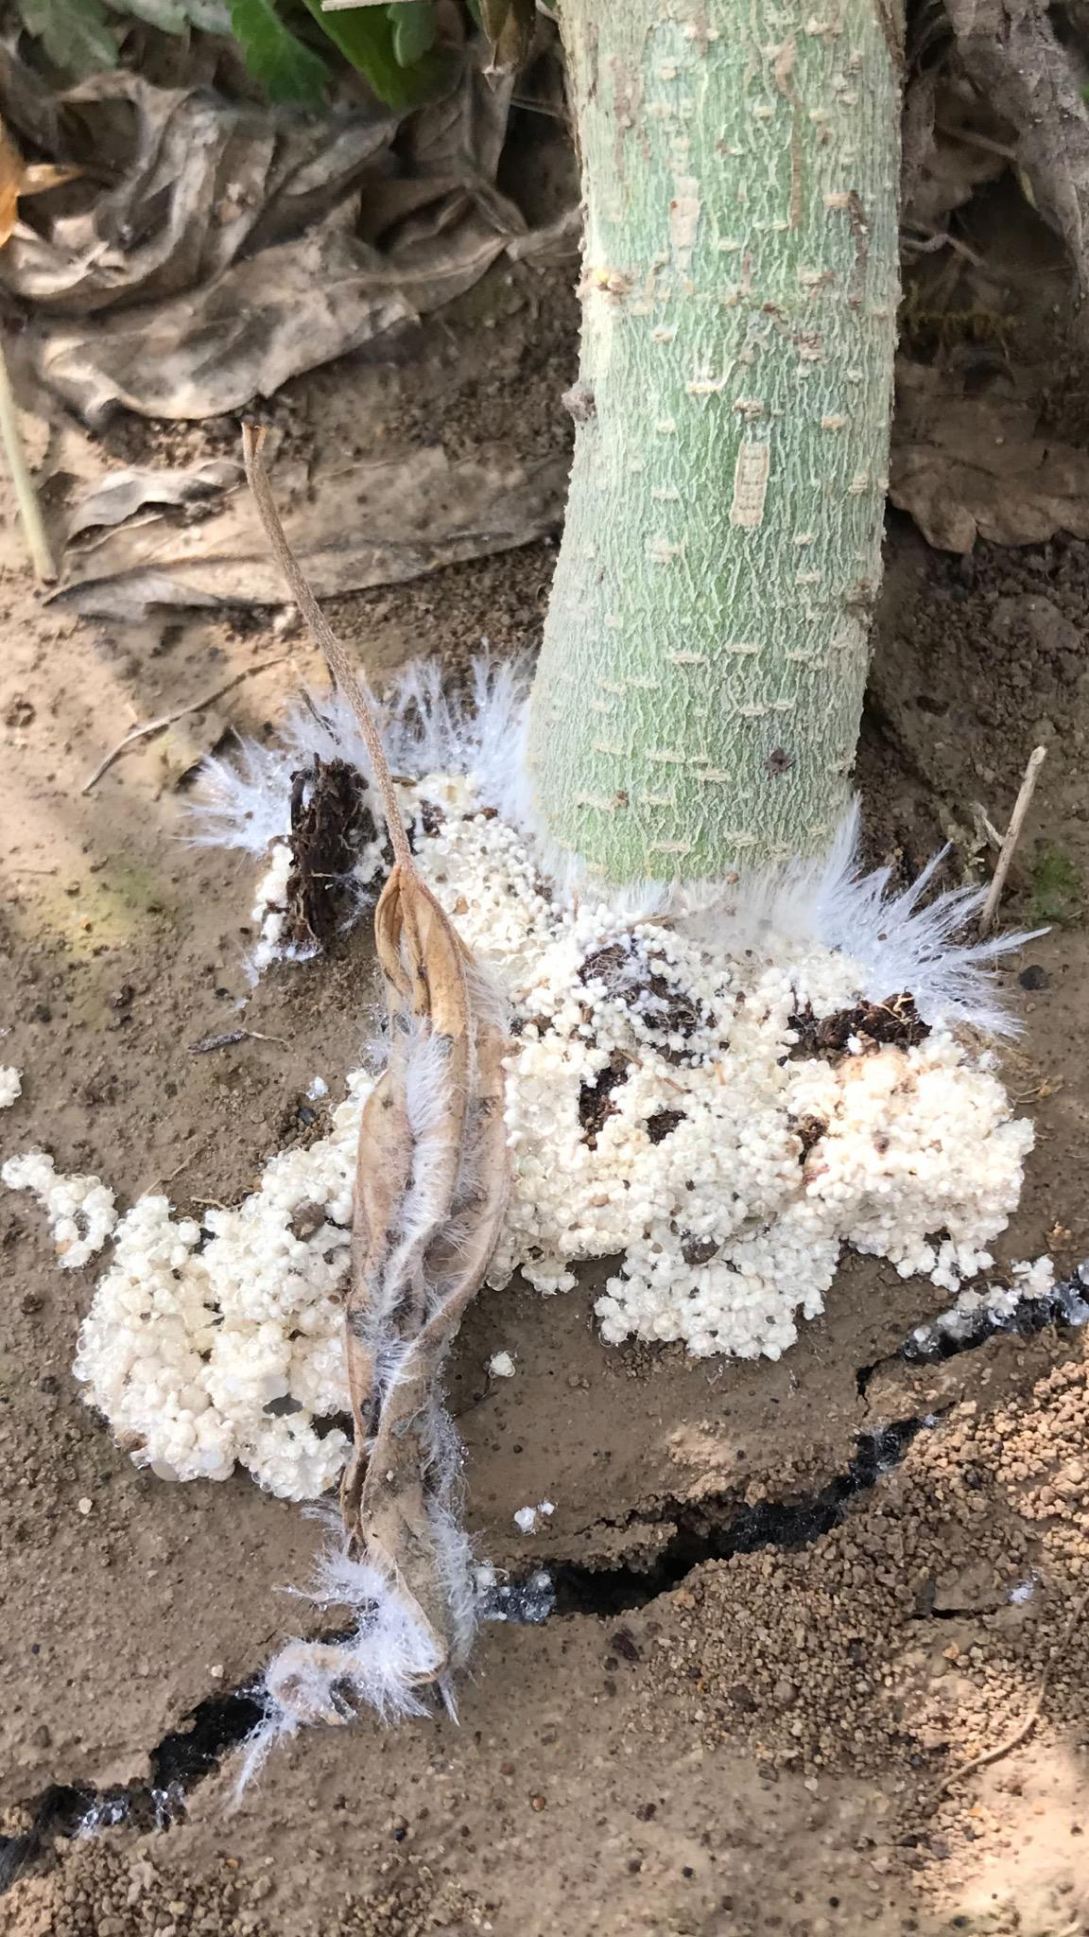
Figure 15. 6 Southern blight causing crown rot with visible mycelium growing where the stem of the plant meets the soil. Photo credit to Dr. N. Gauthier.
Athelia rolfsii is capable of sexual reproduction, but this is rarely observed in natural conditions. Under laboratory conditions, factors like nutrient concentration, light, and culture age can trigger the formation of sexual spores (basidia) on a specialized structure called a resupinate fruiting body, which is a flat, crust-like mat of hyphae (Fig. 9). While sexual reproduction is possible, A. rolfsii predominantly propagates asexually through the production of sclerotia, which can survive in the soil until a suitable host plant is available.
Prevention and Treatment
Athelia rolfsii is difficult to manage once it infects a field, primarily because of its ability to persist in soil as sclerotia for several years. The first defense against Southern Blight is avoiding the use of infected fields and preventing the transfer of inoculum via soil, equipment, or personnel. If an infected plant is identified, it should be removed along with the surrounding soil and incinerated to prevent the spread of the fungus.
Several management strategies can be employed to control Southern Blight:
- Biological Control:
  - Trichoderma species, such as T. harzianium and T. koningii, are effective biocontrol agents. These fungi act as mycoparasites, parasitizing A. rolfsii’s mycelium and sclerotia (Latunde-Dada, 1993). Using Trichoderma in the soil may help reduce the pathogen population, although effectiveness can vary depending on environmental factors (Elad et al., 1984; Punja, 1985).
  - Enhancing soil microbiology by inoculating the soil with high-quality compost may also reduce sclerotia germination, as soil microorganisms can outcompete or inhibit A. rolfsii growth (Punja, 1985).
- Cultural Practices:
  - Crop rotation with non-susceptible plants, such as grasses like corn and switchgrass, may help reduce the pathogen’s presence in the soil (Kator et al., 2015).
  - Good sanitation practices, such as cleaning soil and equipment between crop cycles, can help prevent the spread of sclerotia.
  - Soil solarization can be used in warm climates to kill fungal spores and sclerotia by exposing the soil to high temperatures for extended periods.
- Soil Amendments:
  - High nitrogen applications, particularly those that release ammonia (NH3), may reduce A. rolfsii populations. This could be due to toxic effects on the fungus or a boost in soil microbial activity, which may suppress the pathogen (Faruk et al., 2010).
- Chemical Control:
  - Chemical fungicides are not typically recommended for Southern Blight, as they can disrupt beneficial soil organisms and may be less effective in the long term. They should be considered a last resort after other measures have failed.
- Plant Extracts:
  - Research has shown that Cannabis sativa plant extracts can have activity against A. rolfsii (Faruk et al., 2010). This opens the door for the potential use of Cannabis-derived compounds in managing Southern Blight, although further research is needed to evaluate their efficacy.
Athelia rolfsii (Southern Blight) is a significant threat to Cannabis and many other crops, particularly in warm, moist environments. Its ability to survive as sclerotia in the soil for extended periods makes it a challenging pathogen to manage. However, using a combination of biological control agents, crop rotation, soil amendments, and good field hygiene can help mitigate the impact of this fungus. Breeding resistant Cannabis varieties and exploring natural plant extracts, like those from Cannabis itself, may offer promising avenues for future disease management strategies.
In summary:
- Vascular wilt is another general term used to describe pathogens that causing wilting symptoms in infected plants, caused by various fungal species
- Species in the genus Fusarium are a culpable agents that is a generalist and can infect a number of different host plants
- Verticillium, Macrophomina and Althelia are other common genera that cause wilt
- Spores of fungi that cause vascular wilts can persist in soils for years

Chapter 16
Hemp Canker

Kingdom: | Fungi | Fungi | Fungi | Fungi | Fungi
Phylum: | Ascomycota | Ascomycota | Ascomycota | Ascomycota | Ascomycota
Class: | Leotiomycetes | Dothideomycetes | Dothideomycetes | Dothideomycetes | Sordariomycetes
Order: | Helotiales | Pleosporomycetidae | Pleosporomycetidae | Capnodiales | Hypocreales
Family: | Sclerotiniaceae | Didymellaceae | Didymellaceae | Davidiellaceae | Nectriaceae
Genus: | Sclerotinia | Phoma | Ascochyta | Cladosporium | Fusarium
Species: | S. sclerotiorum & S. minor | P. cannabis, P. exigua, P. glomerata, P. herbarum, P. piskorzii, P. nebulosa | A. cannabina, A. arcuata | C. herbarum, C. resinae, C. tenuissiumum, C. cladosporioides | F. sulphureum, F. avenaceum, F. sulphurem, F. graminearum.

A canker is simply a name given to a disease expression that is caused by any number of bacteria or fungi. The symptoms typically include a lesion on the stem that can be irregular and sunken, swollen, flattened and/or cracked. Hemp canker on Cannabis is usually first detected by white mycelium growing on the stem, often near nodes, that can later produce small black sclerotia (Fig. 1). This can girdle the stems, thus killing the plant entirely. Unfortunately, by the time this pathogen is detected, usually it is too late to save the affected plant. Sometimes, the fungus grows within the pith of Cannabis, presenting as a wilt before fungus is obvious on the outside of the stem.
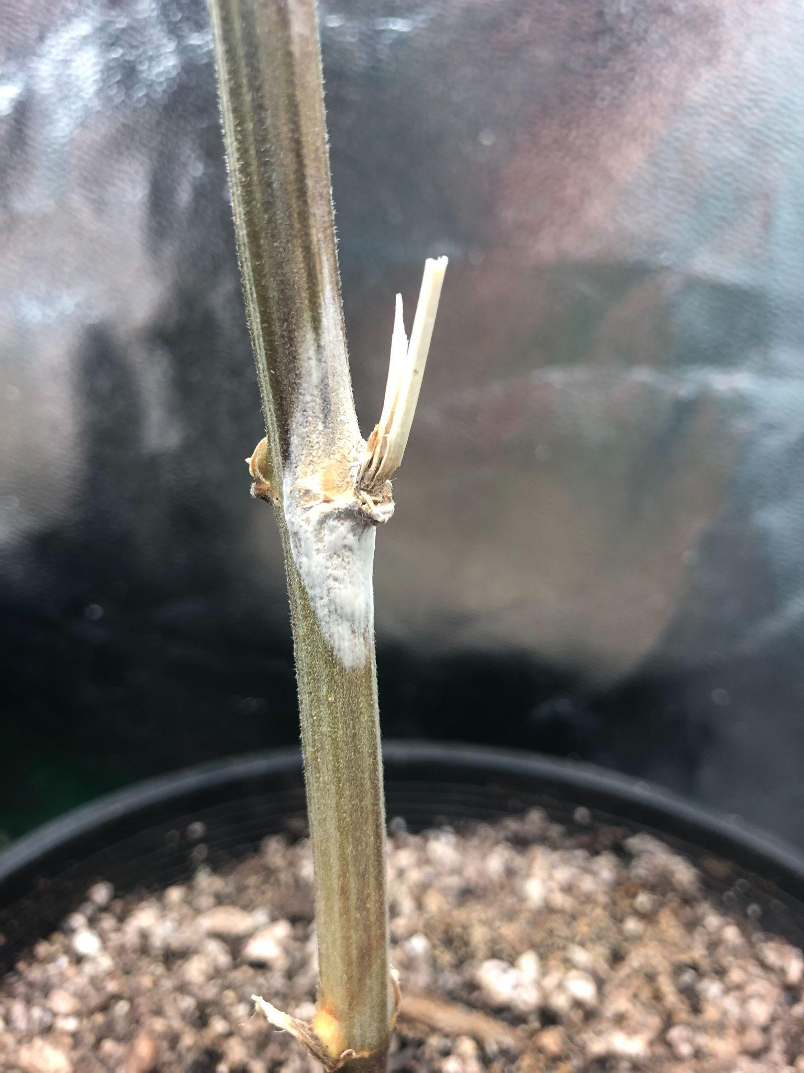
Figure 16.1. Sclerotinia sclerotiorum growing on Cannabis indica indoors in a grow tent. Note the white fuzzy growth directly on the stem.

As Cannabis cultivation becomes more and more wide-spread, diseases that were once few and far between are becoming ever more common. Such is true with canker diseases in Cannabis plants. Unfortunately fungi causing cankers (or Hemp Cankers in particular) are generalist pathogens that are able to parasitize a number of different plant species. The symptoms of Hemp Canker can start out as cotton-like mycelium growing on the stem or near a nodal branch (Fig 2).
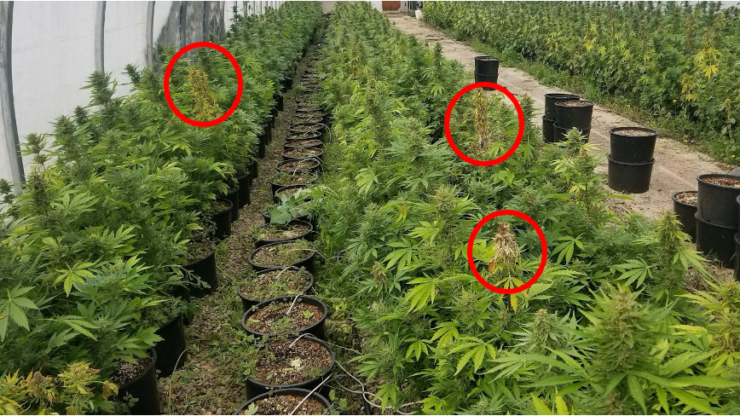
Figure 16.2 The dead tops that can be seen throughout this greenhouse were caused by S. sclerotiorum girdling the stem from within. Sclerotia were formed inside the stem within the pith. Circles indicate infected flowering colas.

Hemp Canker is a disease typically caused by Sclerotinia sclerotiorum or S. minor. These fungi can infect over 350 different species of crops from a diversity of plant families. Purdy considers S. sclerotiorum one of the most nonspecific, omnivorous, and successful of all plant pathogens (Purdy, 1979). This pathogen broadley affects Cannabis gene pools (Sharma et al. 2016).
Diseases caused by S. sclerotiorum are also known as cottony rot, watery soft rot, stem rot, drop, crown rot, blossom rot, and probably other names as well. Many other fungal species can cause canker infections on Cannabis, though it is most commonly caused by S. sclerotiorum.

Biology & Lifecycle
Sclerotinia sclerotiorum and S. minor are ascomycetes within the family Sclerotiniaceae, occupied by many other plant parasites, including Botrytis. Sclerotina are necrotrophic pathogens; capable of growing saprophytically, but are weak competitors. However, like Botrytis, when they infect living hosts they require senescing host plant tissue to colonise and mount a necrotrophic attack. Once established as a weak saprophyte on dead or dying host tissue, Sclerotinia attempts an enzymatic assault on nearby living host tissue in order to actively kill and consume it. These fungi produce an array of extracellular enzymes, including oxalic acid (a known virulence factor of plant pathogens), to damage and weaken the host cells prior to infection (Petrofeza and Nasser 2012).
Growth first appears as white cottony mycelial growth before forming hardened black structures (sclerotia). Mycelial growth and sclerotia formation may occur covertly within the stem, usually killing the plant above the diseased area. Sclerotinia spp. disseminate via windborne ascospores produced in mushroom-like apothecia similar to Botryotinia (grey mold). Unlike Botryotinia, the sexual stage of the asexual Botrytis, Sclerotinia does not have a cooresponding asexual stage. Therefore, within canopy disease amplification does not occur, rather infections represent unique isolates originating from apothecia in the environment, or soil borne infections.
Sclerotia, which are stone-like, hardened, melanized hyphal structures that look like hardened bits of charcoal, and are produced during the growing season within or on their previous plant host. Sclerotinia produces these structures to overwinter in the soil or in host plant debris at rest until the environment becomes favorable to growth again. When environmental conditions are favorable, fruiting bodies arise directly from the previous seasons sclerotia to produce sexual, wind- (or occasionally insect-) dispersed ascospores. Sclerotia may also germinate vegetative hyphae and grow through the soil to infect physically proximate plants asexually, even though no asexual spores are produced.
Sclerotinia can grow in a wide variety of environmental conditions, which helps make it so successful. Although this fungus prefers cool, moist climates, it has also been documented in hot dry areas as well and has been shown to grow from 0-32oC, with impeded growth nearing either extreme (Purdy, 1979).

Prevention and Treatment
Sclerotinia are widely dispersed pathogens with wide host species ranges. Specific infection sources may be shared equipment and sclerotia in seed lots. The seed coat of seed itself may also harbor infective Sclerotina (Sharma et al., 2016). Antifungal seed treatments should be used for seed suspected of harboring pathogens (see chapter on Botrytis).
Sclerotinia sp. thrive in high moisture environments. Sclerotia are dependent on moisture to break their dormancy. Excessive field moisture is positively associated with disease incidence (Abawi and Grogan 1979). Deep plowing (with care not to spread disease via implements) and the incorporation of organic materials can decrease sclerotia survival (Mueller et al. 2002). Prolonged flooding (3-5 weeks) may also be effective for heavily infested fields (Steadman 1979). However, Steadman also noted that subsequently ensuring well drained soil during the growing season is key for limiting disease pressure. Long crop rotations (3+ years) with cereal crops or other non-host plants can reduce inoculum density, though sclerotia may survive in dormancy for many years.
Microbial treatments, including Trichoderma viride (Pankaj et al 2011) and combinations of Pseudomonas aeruginosa, Trichoderma harzianum and Bacillus subtilis (Jain et al, 2015) were effective at reducing disease incidence and improving plant vigor in the presence of Sclerotinia.
In summary:
- A canker is a type of plant infection caused by bacteria of fungi that manifests on the stems of mature plants
- Although first noticed as cottony growth on the stems of plant can this can eventually lead to sudden necrosis in plant shoots

Chapter 17
Leaf Spots
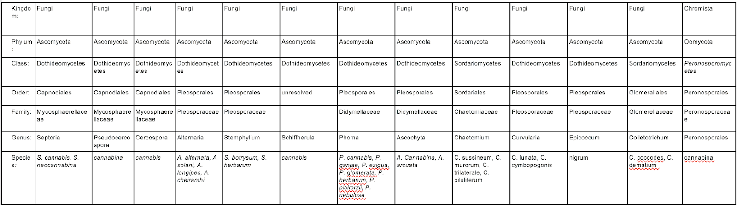

Leaf spot is another general term that is used to characterize numerous diseases caused by a plethora of different bacteria or fungi. As the name suggests, this is a disease that manifests itself on the leaves of plants and appears as a chlorotic spot that eventually dies (necrosis) (Fig. 1). Oftentimes, growers can confuse these infections with nutrient deficiencies. Although not typically as devastating as other fungal pathogens, leaf spots are going to decrease photosynthesis, thereby decreasing sugar production and resulting in poor plant growth and less than optimal yields.
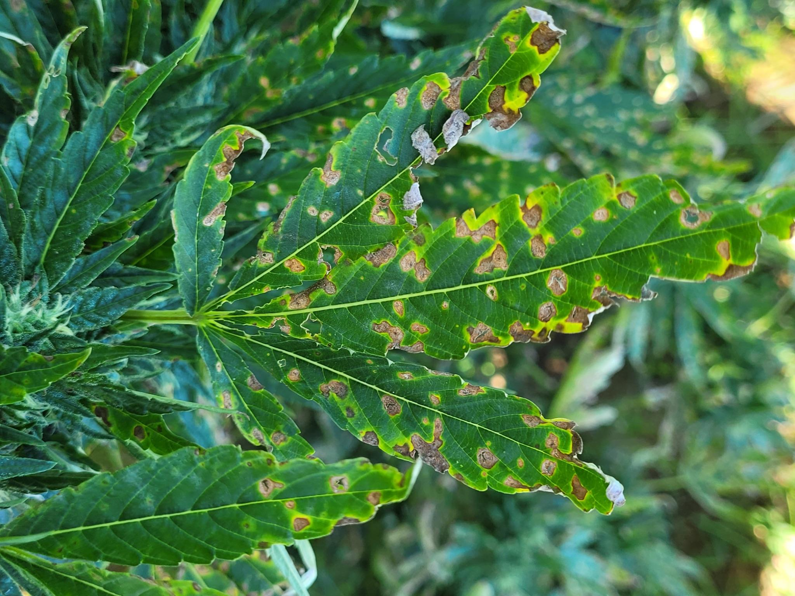
Figure 17.1 Septoria causing leaf spot symptoms on flowering hemp plants. Photo by Dr. Nicole Gauthier.

Some of the fungi that can lead to leaf spots are listed above. Note that all of the ‘true fungi’ in this group are Ascomycetes. The symptoms of leaf spots are generally the similar; irregular or regular botches on the foliage of various plants (Fig 1). In some cases, this can eventually lead to overall defoliation if left untreated.
Typically the features of leaf spots caused by pathogens are distinct from nutrient deficiencies. One common feature of many pathogen-induced leaf spots is the presence of a halo of necrotic tissue around pathogen infected tissue. This represents the host plant’s attempt to wall off the pathogen from living tissue by killing plant cells surrounding the infection in a systemic acquired resistance (SAR) induced hypersensitive response.
Biology
Spores from casual fungi land on susceptible plant surfaces, germinate, and form an appresoria with which they penetrate the plant surface to gain access to internal plant tissue. Leaf spot organisms cause localized infections. Some may exist as asymptomatic endophytes for a period of time or under certain conditions before causing disease. For instance, Alternaria is commonly isolated as an endophyte from a broad variety of host plants, including Cannabis, though it is also recognized as a leaf spot pathogen (Taghinasab and Jabaji 2020).
Nearly all fungi which cause leaf spots either reproduce exclusively via asexual conidiospores (Cercospora, Pseudocercospora, Alternaria), or primarily so (Septoria). Because of this, secondary disease cycles can rapidly progress within a single season from a small initial inoculum source. Septoria also may form sexual fruiting structures (perithecia), persisting overwinter on crop debris where it forms sexual fruiting bodies and disseminates via ascospores the next season (O’Connell et al. 2005).

Prevention and Treatment
Ensuring plants are healthy, vigorous, and pathogen free from the start is important for
avoiding leaf spot diseases. Proper plant nutrition will reduce disease occurrence and severity; nitrogen deficiencies are associated with leaf spot. Because leaf spot organisms survive on crop debris through the off-season, removing diseased crop residue and encouraging high saprophytic activity in the soil can reduce inoculum load and survival.
All of the pesticide applications used for powdery mildew can be utilized against leaf spot fungi (Table 11.1). Foliar applications of compost teas or other microbial inocula throughout the vegetative growth phase may also reduce leaf spot occurrence. Kumar et al. found that in competition studies Trichoderma harzianum, T. viride, and T. virens all were able to outgrow leaf spot causing fungus Alternaria alternata (Srivastava et al 2012). The same study showed that of the three Trichoderma species tested, T. viride was able to directly parasitize and lyse the hyphae of the pathogen (Srivastava et al 2012).
Breeding resistant cultivars may be the most economical and ecologically feasible way to develop plants that are more resistant to certain fungal pathogens (Danon et al. 1982). However, developing resistant varieties to leaf spot fungi will only be adventitious if the resistance offers broad protection against the large range of fungi capable of causing leaf disease, or in areas where specific pathogen species causing significant losses may be targeted in a breeding program.
Interestingly, Indian researchers found that by creating a 1:1 water extraction with dried Cannabis leaves and mixing the solution with a prepared nutrient agar, this inhibited the growth of A. alternata in vitro (Kumar et al. 2015). This could potentially be a simple solution for leaf spot fungi farmers generally and warrants further investigation.

In summary:

- Leaf spot is another disease named after the plant symptoms that is caused by a number of different organisms, typically bacteria or fungi
- Growing/breeding plants resistant to leaf spot organisms and clean cultural practices can alleviate pressure from these pathogens
- Organic fungicides and biocontrol agents can be used if the disease is severe

Chapter 18
Post-harvest Contamination
Table 1. A partial list of post harvest fungi that affect Cannabis. All of these may cause losses due to rot and spore contamination. Some of these fungi pose human health threats as producers of mycotoxins or as direct human pathogens.

Kingdom: | Fungi | Fungi | Fungi | Fungi | Fungi
Phylum: | Ascomycota | Ascomycota | Ascomycota | Ascomycota | Mucoromycotina
Class: | Leotiomycetes | Eurotiomycetes | Eurotiomycetes | Sordariomycetes | Zygomycetes
Order: | Helotiales | Eurotiales | Eurotiales | Hypocreales | Mucorales
Family: | Sclerotiniaceae | Trichocomaceae | Trichocomaceae | Nectriaceae | Mucoraceae
Genus: | Botrytis | Aspergillus | Penicillium | Fusarium | Rhizopus
Species: | Botrytis cinerea | Aspergillus flavus, A. niger, | Penicillium citrinum, P. paxilli, P. commune, P. copticola | Fusarium oxysporum,  F. solani, F. equiseti | Rhizopus stolonifer

After Cannabis plants are harvested, they’re not just at risk for fungal infections while still alive, but also after they’ve been cut down. Improper drying, curing, or storage can lead to fungal growth on your flowers or concentrates. Common offenders include moldy fungi like Aspergillus, Penicillium, and Rhizopus, which are all pretty widespread and can be found in most environments. As the Cannabis industry continues to grow, we’ll probably see more regulations and testing for these types of fungi in Cannabis products.
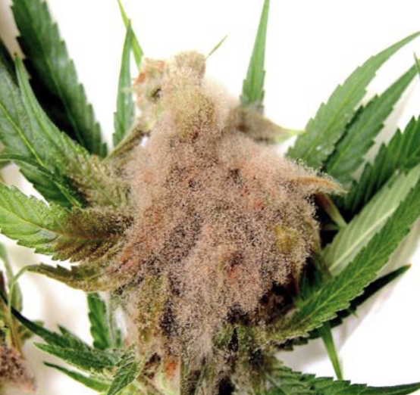
Figure 18.1. Filamentous mold (B. cinerea) growing and sporulating on mature Cannabis flower. Mahmoud et al 2023.
For fungi to grow, moisture is essential. So, if there’s enough water content in your Cannabis, whether it’s flowers, concentrates, or even edibles, those microbial invaders can thrive. That’s why it’s so important for growers to be careful with how they dry, cure, and store their Cannabis products, especially flowers and ice-water hash. Too much moisture or high water potential means fungi will have the perfect conditions to grow. Ideally, dried Cannabis flowers should have about 10-15% moisture content when they’re ready for consumption. With this amount of moisture, the product won’t be too dry or crumbly, and it’ll still retain its aroma, but there won’t be enough moisture for fungi to grow.
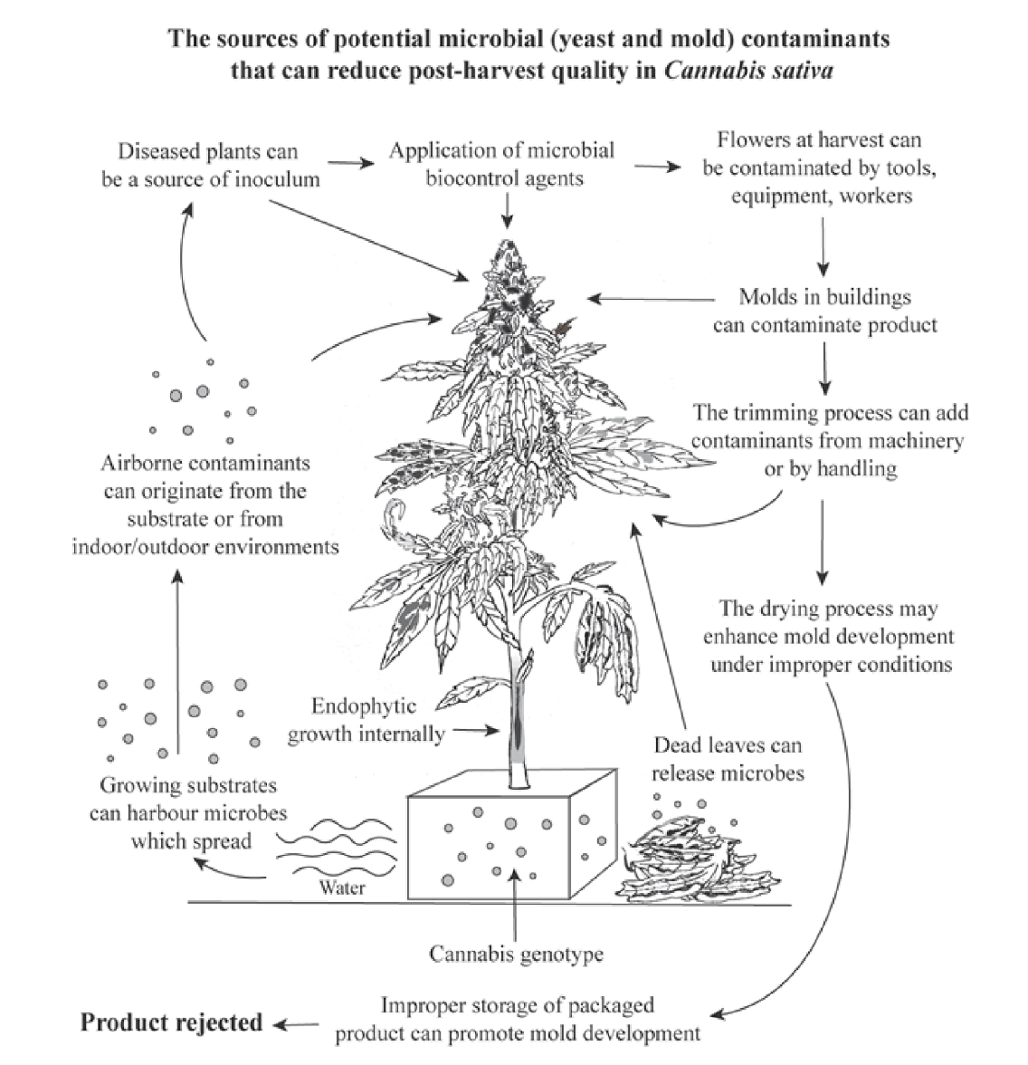
Fig 18.2 Potential sources of Cannabis flower contamination post harvest. Punja et al 2023.

If the flowers are dried and stored properly, they can last for a long time with very little risk of mold. As long as moisture doesn’t get added back to them, the fungi won’t have much of a chance. Glass jars with tight-fitting lids are great for long-term storage on a small scale. On a larger scale, airtight buckets (like 5 or 55 gallons) can be used, especially if stored in cold temperatures or buried underground to keep things cool. For extra shelf life, some growers use nitrogen gas to purge the air from storage containers, which helps slow down oxidation.
Table 18.2. Water activity is a measure of vapor pressure within drying Cannabis flowers divided by the partial vapor pressure of water at the same temperature.
aw=p/p*
aw= water activity | p= partial vapor pressure within the flower | p*=partial vapor pressure of water at a given temperature

Now, the first few days after harvest are a critical time for mold growth, but if the moisture in the flowers drops quickly enough, the risk of mold will be minimized. This is where measuring water activity becomes important. Water activity (often abbreviated as aw) measures how much free water is available for microorganisms to use. It’s different from moisture content, which just tells you how much water is in the material as a percentage of its weight.
Water activity is measured on a scale from 0 to 1, where 0 is completely dry and 1 is pure water. Most fungi need an aw of over 0.7 to grow, so Cannabis flowers should reach an aw of 0.8 as quickly as possible, ideally within a few days. After that, drying should continue slowly at a cool temperature for several weeks. Once the flowers hit an aw of 0.6, they’re ready for curing. Some states like Oregon, Colorado, and California even have regulations requiring flower to have an aw below 0.65 to prevent spoilage.
Table 18.3 Water content benchmarks through the drying process.
Stage | Water activity (preferred) | Moisture content⁴
fresh | >0.9 | 90%
drying | <0.8-0.65 | <16-12%
curing | 0.7-0.6 | 12-11%
storage/use | <0.65-0.6 | <12-10%

For more precise control, growers use water activity monitors, which can range from a few hundred to several thousand dollars, but these are essential for those who need exact measurements. However, moisture content can be checked more cheaply at home. You can weigh a sample of fresh Cannabis, dry it out completely in an oven or dehydrator, and then reweigh it. By comparing the difference in weight, you can calculate the moisture content easily.
Table 18.3. How to measure the moisture content of Cannabis flower.

- Weigh out 100g of flower
- Heat oven to lowest temperature (<200ºF)
- Put flower in oven for 2 hours
- Remove from oven and re-weigh material
- ((Fresh Weight - New weight)/Starting Weight) X 100%=Moisture content

Eg. I have a 100 g sample of Cannabis flower. After dehydrating the sample, the flower weighs 85 grams:

((100-85)/100) X 100%= Moisture content
(100-85)=15
((15)/100) X 100%=MC
(.15) X 100%=MC
Moisture Content=15%

In terms of drying environment, the typical rule is to keep the room at 60% relative humidity or lower, with temperatures below 60°F. However, sometimes this can leave too much room for mold growth, so it can be helpful to drop the relative humidity even lower during the early stages of drying. Using circulating fans will help avoid stagnant air pockets, and cooler temperatures will keep the fungi at bay. This will also help maintain the flower’s quality while it dries slowly, leading to a smoother, more aromatic final product.
Table 18.4 Environmental parameters for drying Cannabis flower to ensure no loss to mold post-harvest
Relative humidity | <60%
Temperature | ~<60oF
Air movement | Steady movement, no still pockets
Lighting | Kept Dark

There’s a bit of debate about what exactly happens during the drying and curing process of Cannabis. While we know there are chemical changes that take place after the plant is harvested, there’s not a ton of research specific to Cannabis. Tobacco, on the other hand, has been studied more due to legal reasons. In tobacco curing, for example, chlorophyll and starches break down while sugars increase (Yamaguchi et al. 2013). Several reactions occur in the process, such as the Maillard reaction between amino acids and sugars, the formation of nitrosamines from nicotine and nitrates, and the breakdown of phenylalanine, which leads to the production of volatile phenols. There’s also oxidation of isoprenoids and carotenoids (Zhu et al. 2016).
Farmers often focus on terpene content throughout the growing and drying stages, but a whole range of other chemical compounds also come into play, like phenols, acetyls, ketones, thiols, and esters. These all work together to create the final scent of Cannabis. As the flower dries and cures, its chemical profile continues to develop. For instance, oxidation of carotenoids (which are tetraterpenoids) produces "rose ketones" like ionones and damascones. These compounds are key to the distinct scent of roses (Yue et al. 2016).
Freeze-drying has been getting attention as a method for drying Cannabis while preserving its quality. Since terpenes and other volatile compounds play a big role in the sensory experience, freeze-drying could be one of the best ways to preserve them. Plus, because the process is fast and done at low temperatures, it reduces the risk of mold growth compared to traditional slow-drying methods.
If the smokeability or overall quality of your final product, adding some heat during the drying process might be worth considering. On a larger scale, some hemp farms that focus on CBD extraction have adapted large hops dryers for Cannabis, allowing them to process huge quantities of biomass. For products like vaporizer pen cartridges, most of the material comes from distillates or isolates, so the original flower quality doesn’t matter as much (though healthier plants will likely have more cannabinoids). For operations that process flowers without purifying them into isolates, though, mold can concentrate mycotoxins, which can be problematic.
If you find mold on your flower after it’s dried, even if you followed the right drying parameters, it's likely that the mold was already growing while the plant was alive. Some fungi, like Aspergillus or Penicillium, can be sneaky and go unnoticed by growers. These fungi are often endophytes (living inside the plant) or latent saprophytes (living off dead tissue).
Most fungi that affect Cannabis aren’t harmful to humans. This includes common molds like Botrytis and powdery mildew (Erysiphales), though inhaling large amounts of spores could cause respiratory issues or trigger allergic reactions in some people. What’s more concerning, however, is that some fungi on Cannabis can produce mycotoxins or even cause human diseases. Certain species of Aspergillus and Penicillium, which are known to produce toxic compounds, can grow on Cannabis as contaminants or endophytes (Mckernan et al. 2015; Taghinasab & Suha Jabaji, 2020). Other fungi, like Cryptococcus and Mucor, which can cause diseases in humans, have also been found on Cannabis intended for human consumption (Thompson et al. 2017; B. Shapiro et al. 2018; Scott et al. 2018).

Mycotoxins

Mycotoxins are a group of compounds produced by fungi that are toxic to those that consume them. Often mycotoxins remain in a particular material (eg. Cannabis flower) long after the fungus has been eradicated.Therefore these chemicals can be quite insidious, commonly avoiding detection.

There are a number of fungal species that produce mycotoxins in Cannabis products and many are found in the genus Fusarium, Aspergillus, or Penicillium. Examples of mycotoxins reported from Cannabis include aflatoxins, T-2 toxins, ochratoxins and trichothecenes. (Gwinn et al. 2023)

Most of these toxic compounds are produced by pathogenic fungi but some can be produced by fungi that are not causing disease symptoms in the host plant.

Luckily, some mycotoxins are destroyed and denatured at temperatures greater than 356oF, whereas cannabis is typically consumed at temperature ranges from 500-700oF (Gwinn et al 2023). However, consuming cannabis tainted with mycotoxins is never recommended, especially for immune-compromised people.

Extraction of mycotoxin-contaminated Cannabis flowers can actually concentrate these compounds, creating even more dangerous products. Therefore proper testing and regulation should be implemented to avoid any potential risk.

Aspergillosis is a disease caused by certain species of the Aspergillus genus. It results in a serious pulmonary infection where fungal mycelium grows in the lungs, and in some cases, it can be fatal. There have been reports of deaths related to Aspergillus-contaminated Cannabis, particularly in people with compromised immune systems (Gargani et al., 2011; Remington et al., 2015). In severe cases, the fungus can form a 3D colony called a "fungus ball" in the lungs, which can invade nearby tissue. Exposure to moldy Cannabis has also been linked to allergic bronchopulmonary aspergillosis, which is an autoimmune response to different Aspergillus species (Llamas et al., 1978).
Aspergillus spores are everywhere in the environment, so you're probably inhaling them right now. For most people with a healthy immune system, these spores don’t cause any issues. However, moldy Cannabis can contain such a high concentration of spores that it can overwhelm even healthy individuals, or trigger severe immune reactions in people with allergies. There’s even been a case where a healthy, non-immunocompromised person who smoked Cannabis regularly was linked to developing cryptococcal meningitis, potentially due to exposure to spores from the flower (B. Shapiro et al., 2018).
Another dangerous fungal infection is mucormycosis, which is caused by fungi in the Rhizopus and Mucor genera. This can lead to severe disfigurement or even death. Some cases of mucormycosis have been linked to medical Cannabis use in diabetic patients (Stone et al., 2019). Additionally, for people who are severely immunocompromised, fungi that usually don’t cause disease in healthy individuals, like Fusarium species, have been known to cause fatal lung infections when inhaled through Cannabis use (Khwaja et al., 2016). One of the most common fungi found on Cannabis in California dispensaries is Purpureocillium, an emerging human pathogen that can cause lung infections (Thompson et al., 2016; Salazar-González et al., 2020). Because of these serious health risks, it’s crucial for Cannabis products to be tested for harmful fungi and grown and processed in ways that minimize contamination.
Microbial testing for Cannabis varies by state. Some states don’t do any microbial testing at all but instead measure things like water activity and moisture content to predict how likely microbes are to grow on the plant material. However, there aren’t yet standardized methods to definitively detect harmful pathogens, and distinguishing them from harmless microbes remains a challenge. As the industry grows, testing methods will likely become more accurate and rigorous. Species-specific tests, such as metabolic or DNA sequencing-based assays, are being developed for Cannabis samples. Until these tests are more widespread, we have to rely on imperfect screening methods and our own senses when checking products before consumption. If there’s any doubt about contamination, or if you’re immunocompromised, extra caution should be taken.
There are post-harvest sterilization options available for Cannabis products. Various extraction and purification methods can recover cannabinoids and terpenes from contaminated flower. While it's harder to ensure that unprocessed flower is completely free from microbial risks, clean extracts are much easier to achieve. Unfortunately, most of the flower remediation methods available to small-scale growers can degrade the quality of the product. Commercial sterilization products, commonly used in the food industry, cause less damage to the quality but can be prohibitively expensive (Table 5).
Table 18.5. Sterilization methods for Cannabis flower. Radio frequency and e-beam radiation have both been reported to remediate Cannabis flower without unacceptable losses in quality.
Category | Method | Benefits | Negatives
Extraction | hydrocarbon, alcohol, CO2, distillation | - Accessible to all scales  - Produces high quality extract product | - Flower may be a preferable product  - Some infrastructure investment and knowledge required  - May concentrate pesticides and mycotoxins
Heat treatments | Steam, autoclave, pressure cooker, dry oven | - Highly effective at destroying nearly all biological contaminants | - Destroys flower  - Degrades and alters cannabinoid content
Non-ionizing radiation | Microwave, Radio frequency | - Capable of sterilization throughout an entire flower sample, not just the surface  - Much less damaging than direct heat treatments | - Degradation in organoleptic qualities still occurs, including losses of terpenes
Ionizing radiation | Gamma, X-ray, electron-beam | - Capable of sterilization throughout an entire flower sample, not just the surface  - Much less damaging than direct heat treatments | - Degradation in organoleptic qualities may still occur, including losses of terpenes  - Gamma radiation requires dangerous radioactive material

Some consumers may be particularly sensitive to any reduction in quality, while others may prioritize eliminating pathogen risks entirely. Farmers need to think about the needs of different consumers across the market, including those who require sterile products. In some regions, there are regulations that set minimum standards for microbial contamination, and in areas where yeast and mold counts are used as the measure (instead of testing for specific pathogens), post-harvest remediation may be required—especially for outdoor crops that are exposed to higher levels of environmental spores, and where air filtration or sterilization isn’t feasible.
It’s important to use your senses when inspecting Cannabis before consuming it. Look for any fuzzy or furry growth on the flower, which could indicate the presence of mold. If the bud feels unusually dry and crumbly, or on the other hand, it feels soft and tears instead of snapping, that could also signal fungal contamination. If the flower doesn’t feel right, take a closer look before using it.
Eventually, you might even be able to see spore-bearing structures (called conidia) forming on the flowers. These can sometimes look a lot like trichomes, so you may need magnification to tell the difference. Using a jeweler's loupe or a dissecting microscope can help you spot mold from the desirable trichomes (Fig. 2). If conidia are well-developed, you may see a cloud of spores when you break apart a bud. While trichomes will fall straight down because of gravity, spores tend to rise up in the air, looking like a puff of smoke.
You can also try sniffing the flower for any moldy smells. Mold releases volatile organic compounds that usually have a foul, musty scent. If the flower smells damp or off, that could be a sign that it’s contaminated with mold and should be discarded.
In summary:
- Even after harvesting cannabis plants there are a number of fungal species that can destroy Cannabis flowers if not dried and stored properly
- Reducing water activity in final products can ensure no fungal growth can occur
- Best practice is to store properly dried cannabis flowers in glass jar in the dark kept around 65oF with little fluctuation

